Python for Beginners

JetBrains Academy

# Introduction Python for Beginners

Topics completed: **0 / 50 (0%)**

You'll complete the track in **15 hours**.

Activities left: **63.**

## What is an Activity?

Activity is a single element of study plan, for example topic, stage implementation, or survey. Note: this total number is updated every 5 minutes.

## Problem of the day

No problems to solve. Complete more topics to unlock this feature and repeat what you've learned.

## Study plan

Goal to become a Python for Beginners

**Your current project:** [Zookeeper](https://hyperskill.org/curriculum#about)

Stages completed: **0 / 4**.

You'll complete the current stage in 25 minutes, the project in 5 hours.

## Zookeeper

### About

This short code challenge can help the local zoo look after its denizens. You will create a tool for monitoring animals and their status.

### Learning outcomes

This project is aimed at our beginners. It helps you understand some syntax basics and learn how to work with variables, data storage types such as lists, and while loops.

### What you’ll do and what you’ll learn

#### Stage 1/4: Rush into print.

First, let's try to get some simple output from your code.

* Introduction to Python
* [Overview of the basic program](https://hyperskill.org/learn/step/5208" \t "_self)
* [Multi-line programs](https://hyperskill.org/learn/step/5233" \t "_self)
* [Stage implementation](https://hyperskill.org/projects/98/stages/539/implement)

##### What you will do in this stage 1/4 : Rush into print

Project: [Zookeeper](https://hyperskill.org/projects/98)

 Medium  2 minutes

###### Description

There are many animals in the zoo, and all of them need care. The animals must be fed, cleaned, surrounded by their kin, and kept happy. That is a difficult task for our large zoo, so one of your employers has suggested a more convenient way to keep track of everything. She wants to be able to pull up a video feed of any animal in the zoo with the help of a program. Being able to check on each habitat would help the zookeepers take care of our furry friends more efficiently!

In this project, you will create a program that helps the zookeepers check on the animals and make sure that they're doing well. Your product will be able to process commands from the zookeepers and display the animals on a monitor.

###### Objectives

To begin with, you will develop a simple printer. Your program should display the text from the output example.

###### Example

Output:

1. I love animals!
2. Let's check on the animals...
3. The deer looks fine.
4. The bat looks happy.
5. The lion looks healthy.

**You are starting a new topic**

Study the theory, answer questions, solve coding problems. When you complete all the topics, you can continue with the stage implementation.

##### Theory: Introduction to Python

3 minutes 0 / 3 problems solved

###### What is Python?

**Python** is a modern general-purpose programming language initially developed by a Dutch programmer named Guido van Rossum in the late 1980s. The name comes from the popular Monty Python show, not the snake as you might think. This language has a clean, uniform and well-readable syntax and is **designed to be easy to learn and use in practice**.

Nowadays, Python is one of the most popular programming languages worldwide according to the [TIOBE](https://www.tiobe.com/tiobe-index/) index and the number of programmers who use it is growing every day. The language has a huge community of developers around the world. If you have a problem, you can always ask other programmers for help or find a suitable answer on a site like [Stack Overflow](https://stackoverflow.com/questions/tagged/python).

Developing software with Python is easy and fun :)



**The Python logo**

Python has a wide range of possible applications, especially in:

* web development
* data science (including machine learning)
* scripting (task automation, e.g. text processing or a simulation of typical user actions)

Less commonly, it is also used in **desktop development**.

**Current topic:** [Introduction to Python](https://hyperskill.org/learn/step/5204) (Stage 1)

**Topic is required for**[: Overview of the basic program](https://hyperskill.org/learn/step/5208) (Stage 1) [and Intro to Machine Learning](https://hyperskill.org/learn/step/10403" \t "_self)

**Table of contents:**

[↑ Theory: Introduction to Python](https://hyperskill.org/learn/step/5204#step-title)

###### Python in data science

Python's huge popularity in recent years is mostly due to its use in data science. What makes it better than other languages for this purpose? Well, there're several reasons:

* its simple syntax allows people from non-programming backgrounds to use it for data processing and model training without spending much time learning a new language;
* Python supports a very large number of third-party libraries for machine learning, neural networks, statistics, and numeric calculations, which makes your job much easier;
* with Python, it is possible to collect, clean, and explore data, as well as train models and visualize the results — all in one setting;
* the Python ML developer's community is very large, so you can always find support for your tasks.

As you can see, Python does have a lot to offer for data science enthusiasts.

###### Short history of Python

Like other programming languages, Python has gone through several versions. Python 1.0 was released in 1994 and laid the basic principles of the language with emphasis on simplicity.

Python 2.0 was released in 2000. This version has become very popular among programmers. Different 2.x subversions (2.6, 2.7) are still used in various projects and libraries. The symbol **x** in 2.x means any subversion of Python 2.

Python 3.0 was the next major version released in 2008. Its broke backward compatibility with its predecessors in order to rid the language of historic clutter and make Python more readable and consistent.

So, today two similar but incompatible versions of Python are commonly in use. **Throughout this course, we will learn Python 3.x**.

###### First program example

Here is a single line of Python code that prints Learn Python to be great! .

print("Learn Python to be great!")

Now, you do not need to understand how this code works, just start to appreciate the syntax looking like English :)

###### Simple Programs

Introduction to Python -> Versions of Python

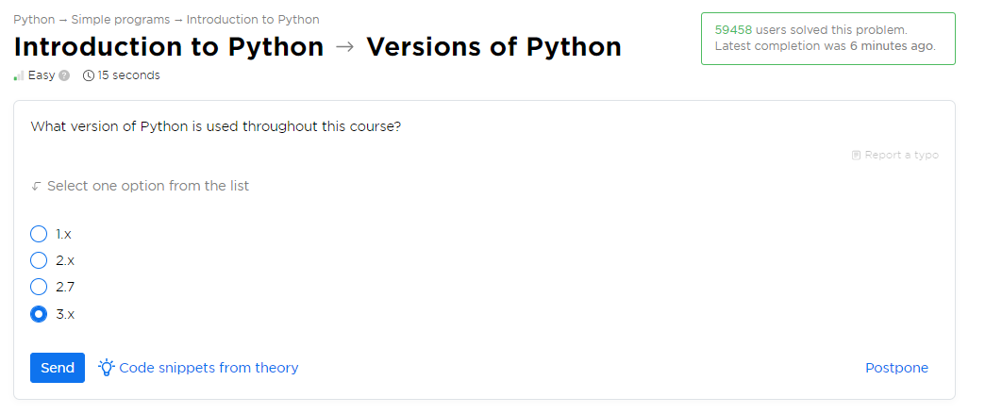

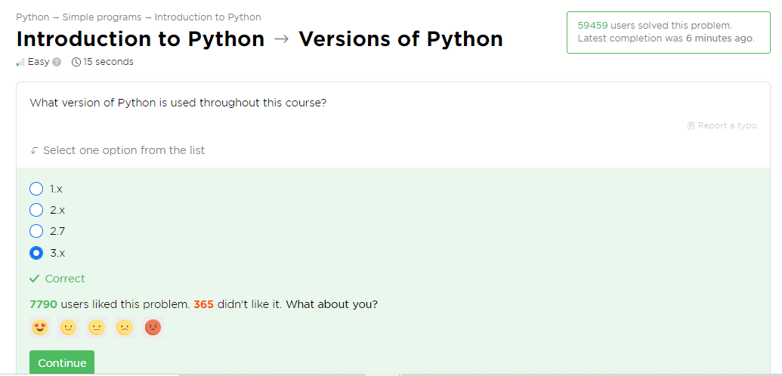

Introduction to Python -> Main applications

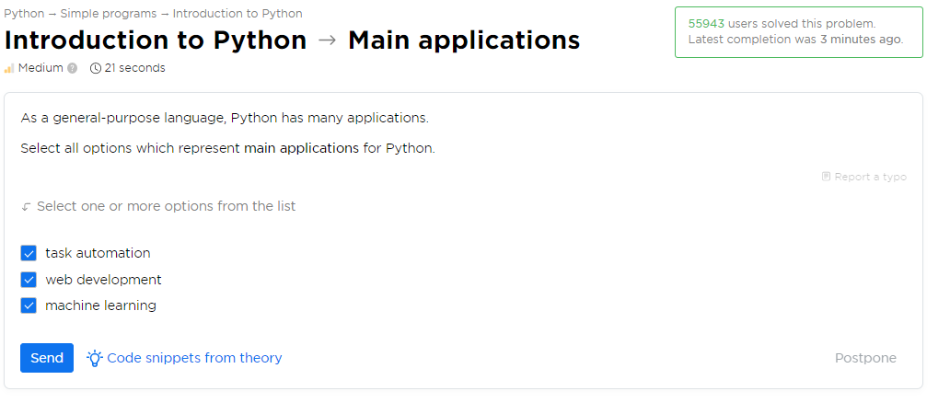

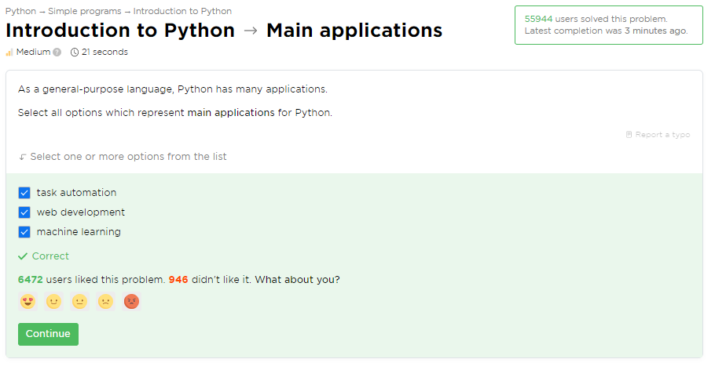

Introduction to Python -> Hello, Python

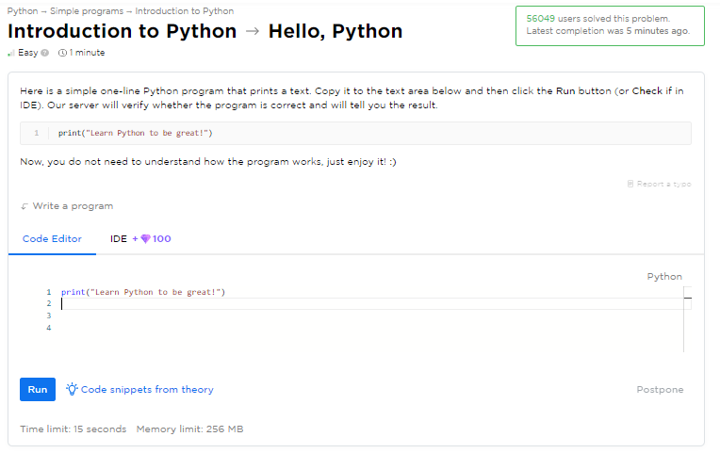

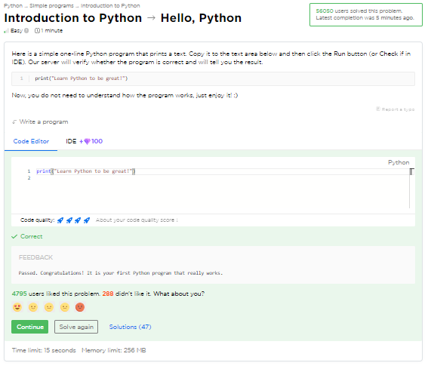

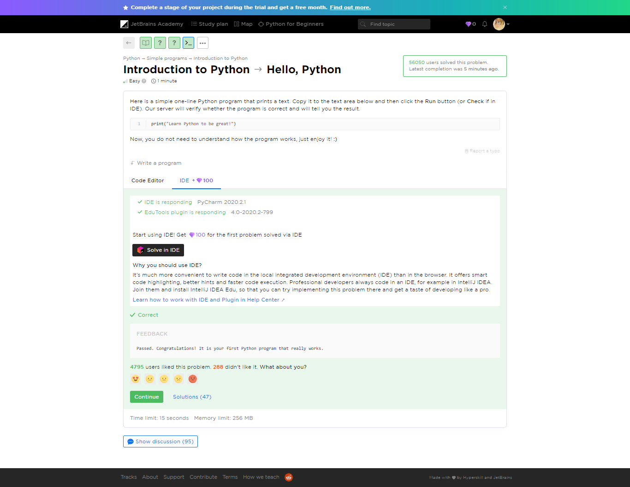

Yaaay!

You completed **Introduction to Python**

**You solved: 3 problems**

1. Versions of Python
2. Main applications
3. Hello, Python

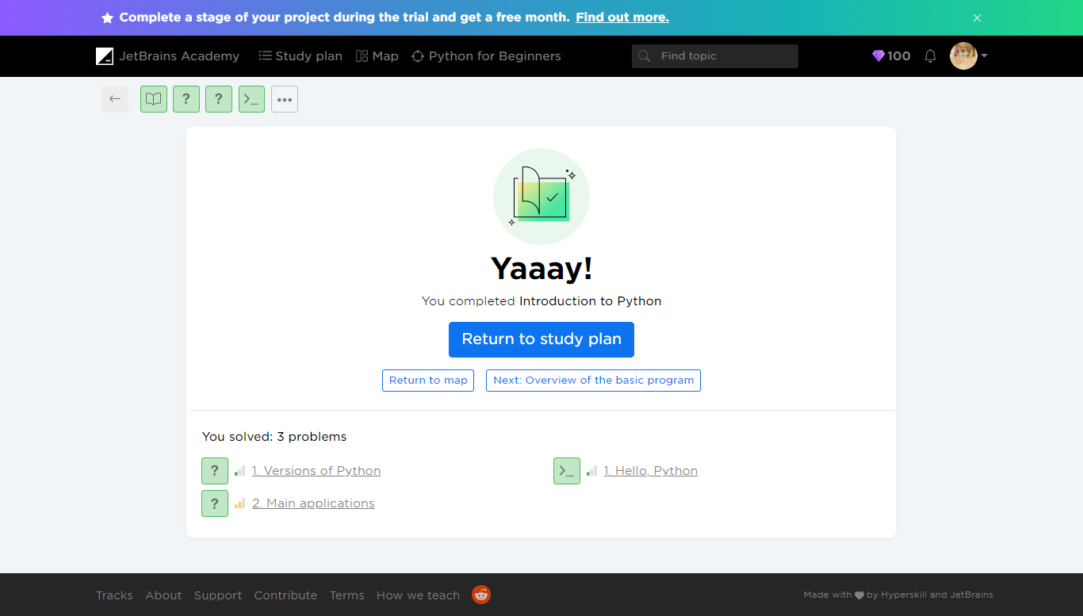

##### Theory: Overview of the basic program

 6 minutes 0 / 5 problems solved

**Table of contents:**

[↑ Theory: Overview of the basic program](https://hyperskill.org/learn/step/5208#step-title)

[§1. The Hello World program](https://hyperskill.org/learn/step/5208#the-hello-world-program)

[§2. Short explanation](https://hyperskill.org/learn/step/5208#short-explanation)

[§3. Printing quotes](https://hyperskill.org/learn/step/5208#printing-quotes)

[§4. Possible errors](https://hyperskill.org/learn/step/5208#possible-errors)

In this topic, you will learn how to develop your first Python programs. Despite the fact that these programs are quite simple, they are still syntactically correct and show that programming in Python is a treat.

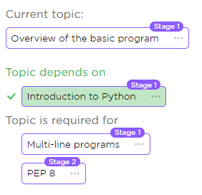

###### The Hello World program

Our first example will be **Hello, World!** It is traditionally used to introduce beginners to a new programming language.

print("Hello, World!")

As you can see, it consists of a single line and just prints a string passed in the parentheses, but without quotes. You may run this code [online](https://repl.it/languages/python3) (just copy it and click on the triangle) or follow these [installation tips](https://www.python.org/about/gettingstarted/#installing). You should get this result:

Hello, World!

Although this code is very simple, we will go through it in some more detail.

###### Short explanation

Here,**print** is the name of a function. A **function** is a block of code that does some useful work for you, e.g. prints a text. In some sense, a function is a subprogram that can be reused within your programs. When the name of a function is followed by parentheses, it means that it was **called** to get the result.

Let's go further, **"Hello, World!"** is a Python string. All strings are surrounded by either single or double quotes, so **'Hello, World!'** is also a valid string. You may replace this string with another one, and the program will print the new string. For example:

print('Python 3.x')

As you might guess, this program will print:

Python 3.x

###### Printing quotes

If you would like to include quotes into a string, then enclose this string in quotes of another type, e.g.:

print("Yes, I'm ready to learn Python.")

It prints:

Yes, I'm ready to learn Python.

You can try to run all the examples using the [link](https://repl.it/languages/python3) provided earlier. This will help you familiarize yourself with Python.

###### Possible errors

Even this simple line of code may contain errors, most common of them are:

* **putting extra indentation**

   print("Hello, World!")

This does not work because of extra spaces before **print**.

* **calling the function by the wrong name**

pint("Hello, World!")

This line contains **pint** instead of **print.** Make sure to refer to every function by its proper name.

* **writing names in the wrong case**

PRINT("All caps")

Again, **Print**, **print** and **PRINT** are not the same. Names are case-sensitive in Python.

* **missing one or both quotes for a string**

print("Python)

This does not work because of missing closing quotes.

* **missing one or more parentheses**

print("I have no end"

Be careful with parentheses, especially when calling a function.

Now you shouldn't have any serious trouble with such programs.

###### Problems

Overview of the basic program  -> Print a text

 Medium  1 minute

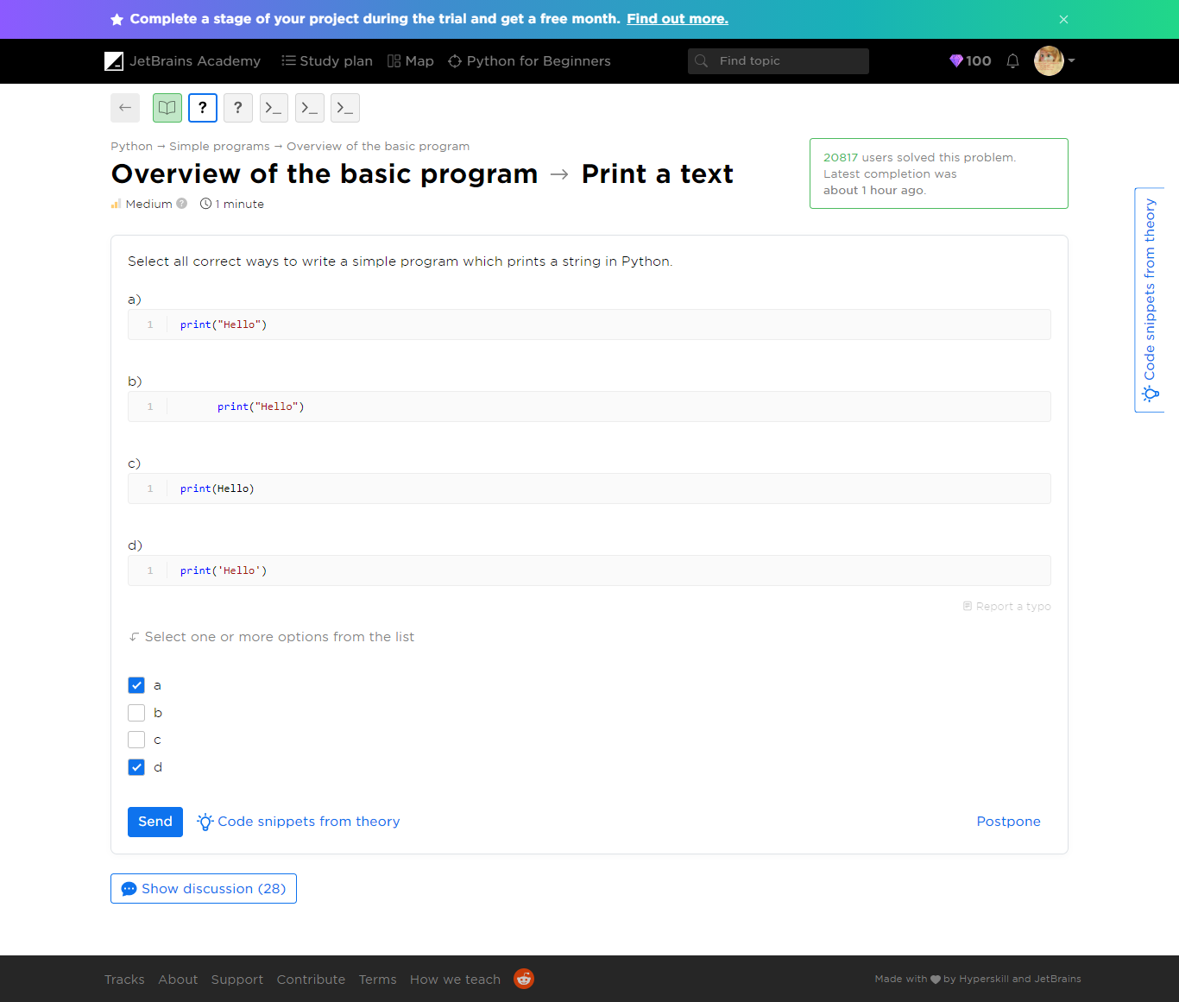

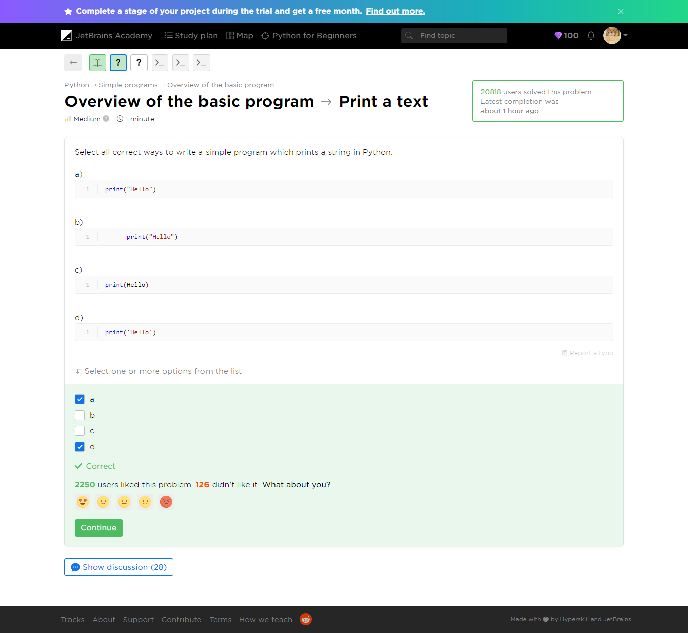

Refer to ***print-a-text.py*** file

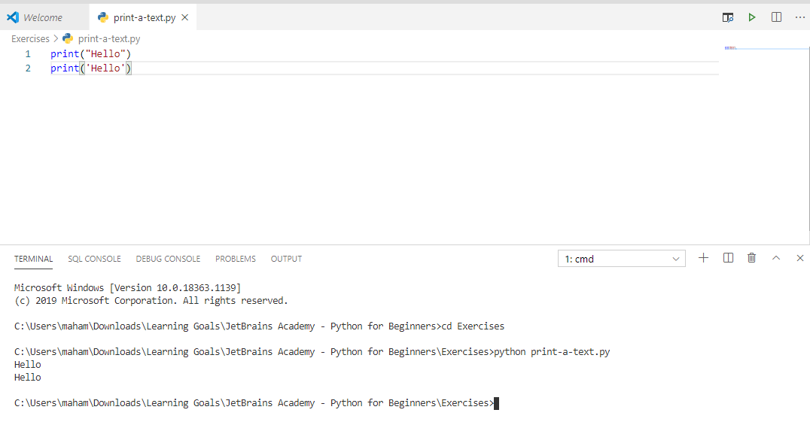

Overview of the basic program  -> Multiple quotes

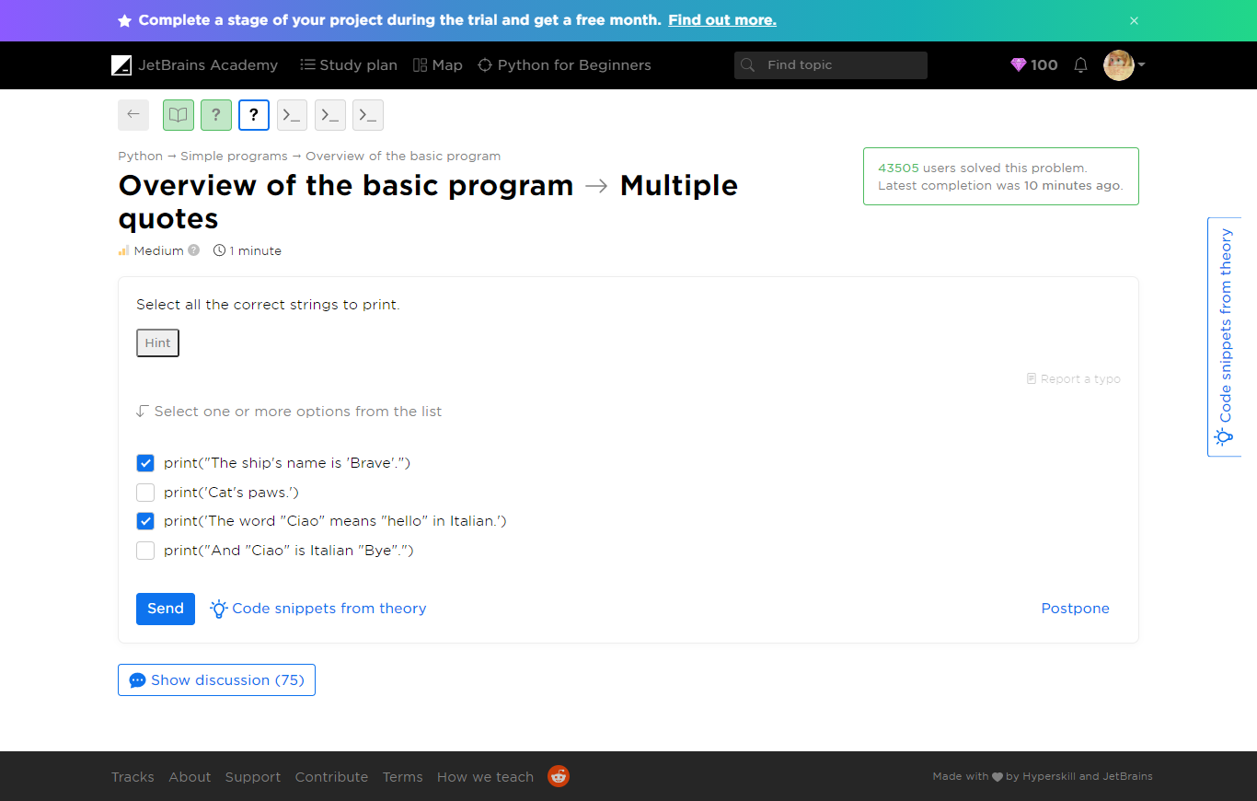

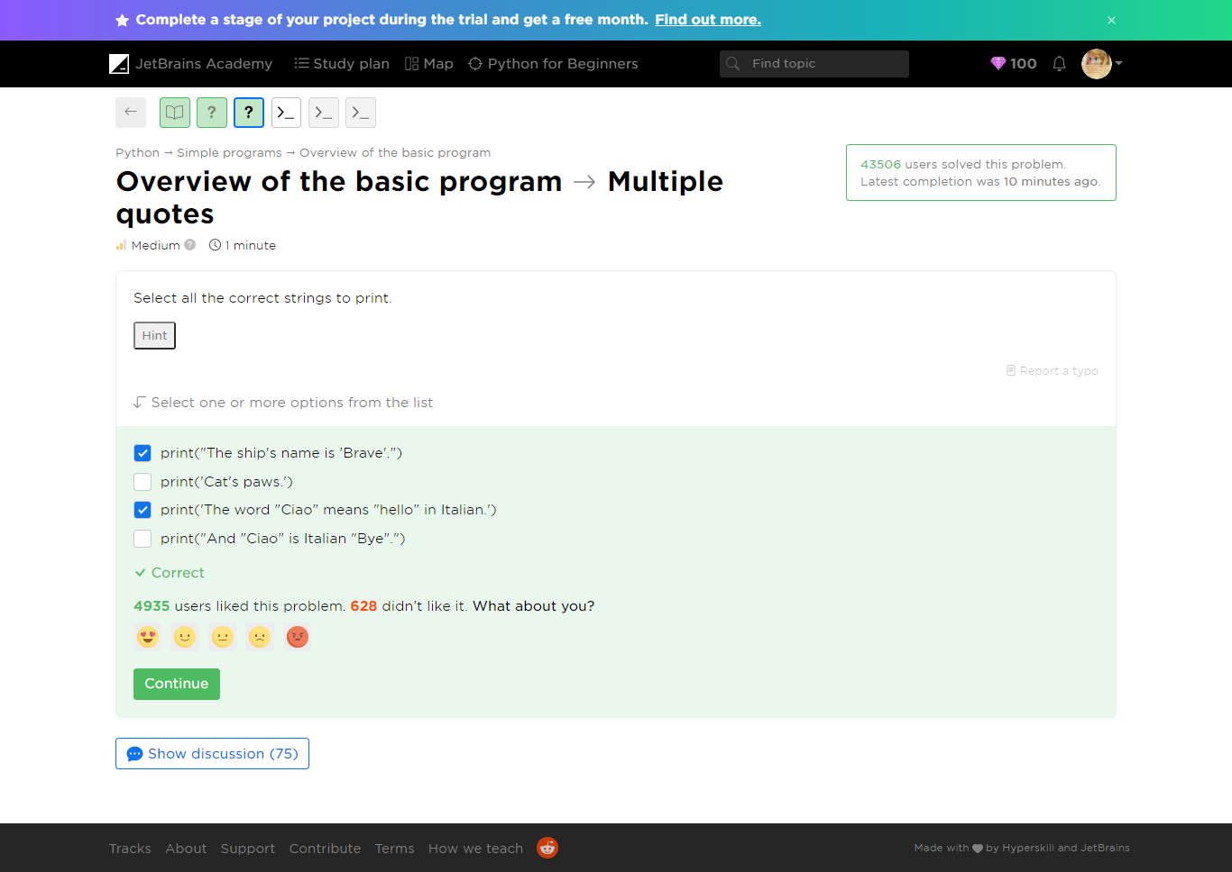

C:\Users\maham\Downloads\Learning Goals\JetBrains Academy - Python for Beginners\Exercises>python multiple-quotes.py

File "multiple-quotes.py", line 2

print("And "Ciao" is Italian "Bye".")

^

SyntaxError: invalid syntax

C:\Users\maham\Downloads\Learning Goals\JetBrains Academy - Python for Beginners\Exercises>python multiple-quotes.py

File "multiple-quotes.py", line 3

print('Cat's paws.')

^

SyntaxError: invalid syntax



Refer to ***multiple-quotes.py***

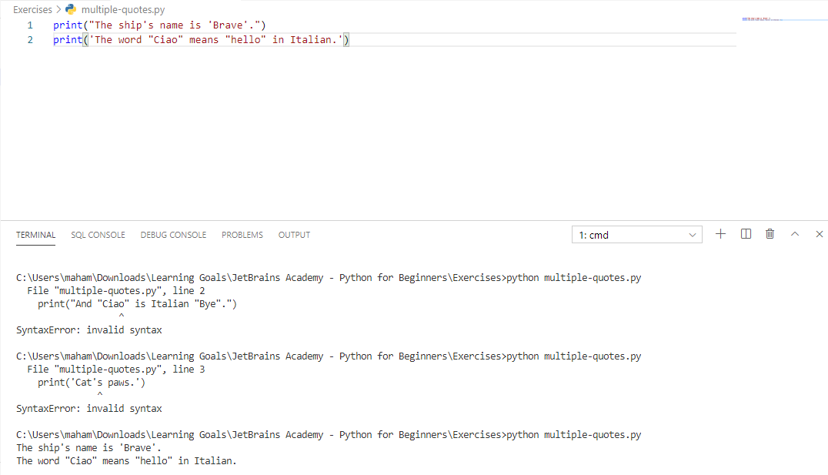

Overview of the basic program -> Your name

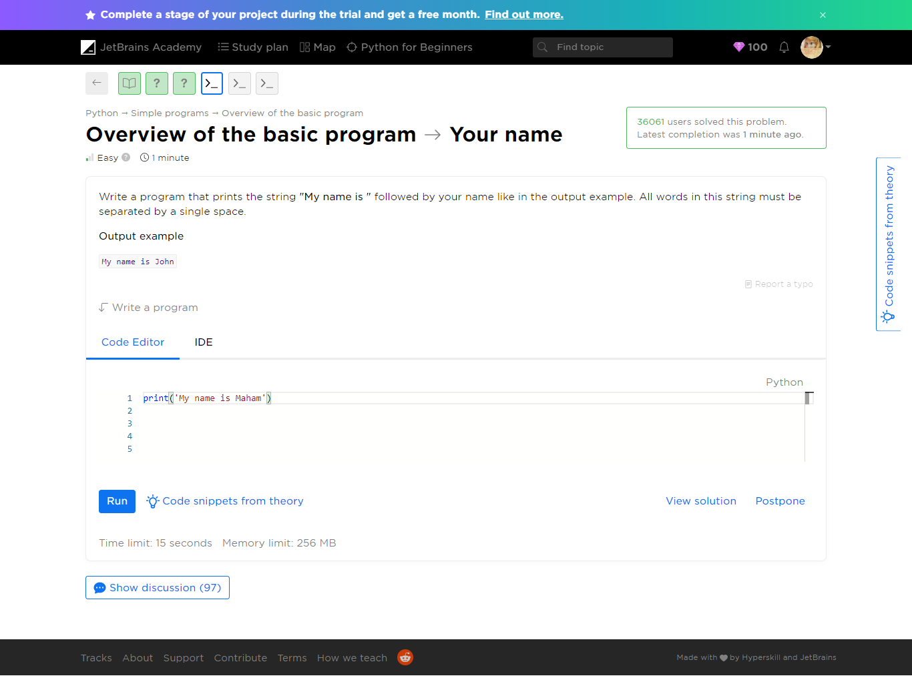

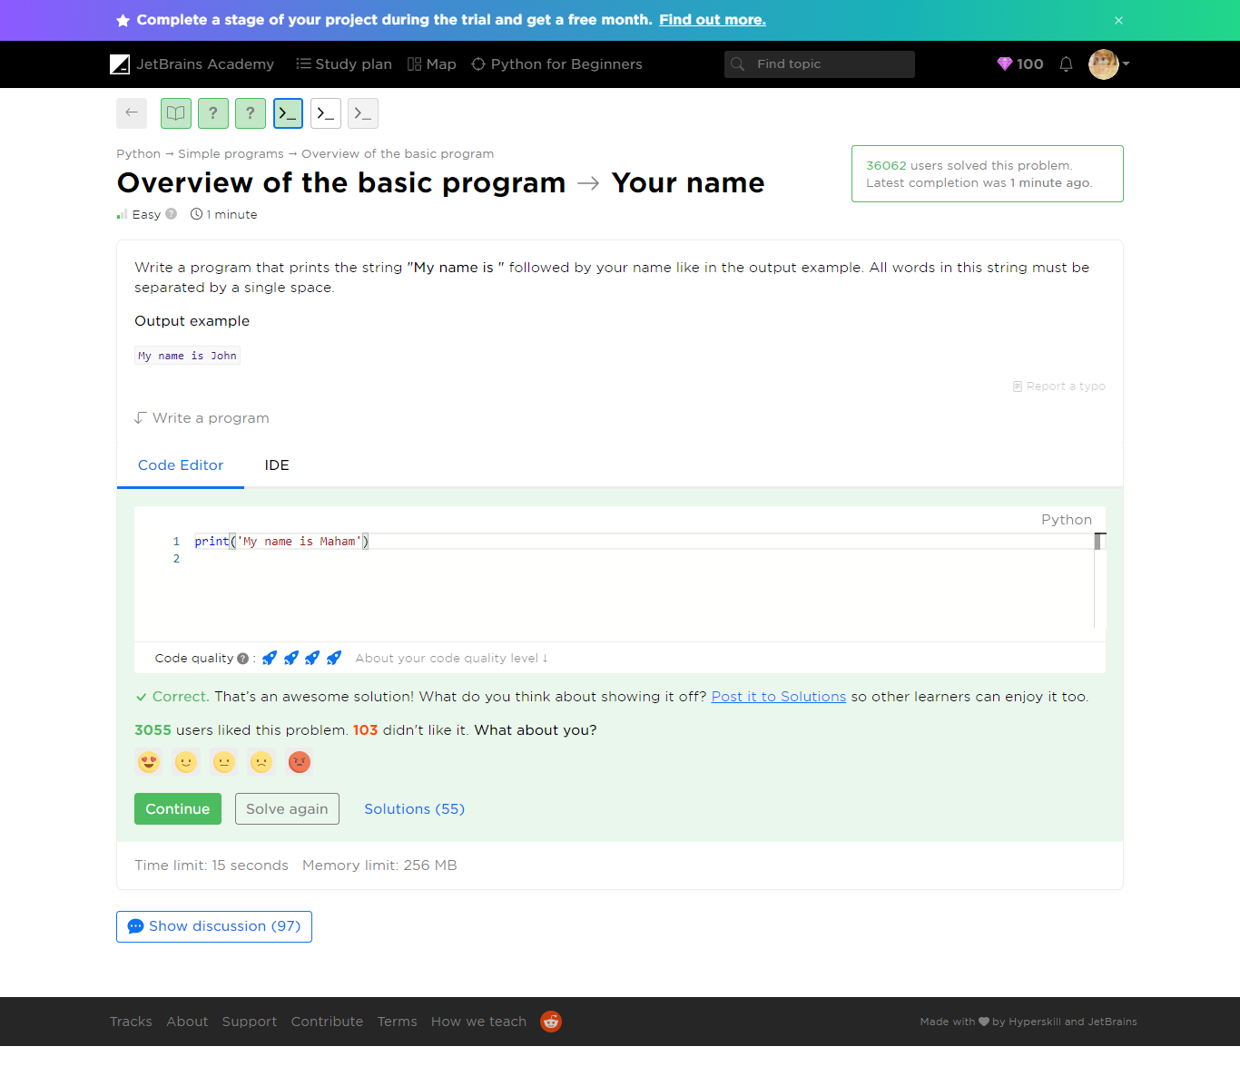

Refer to ***your-name.py***

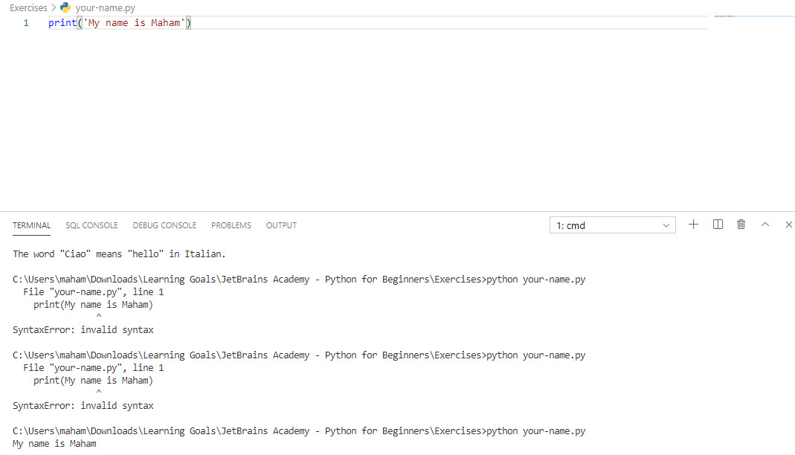

Overview of the basic program -> Alice in Wonderland

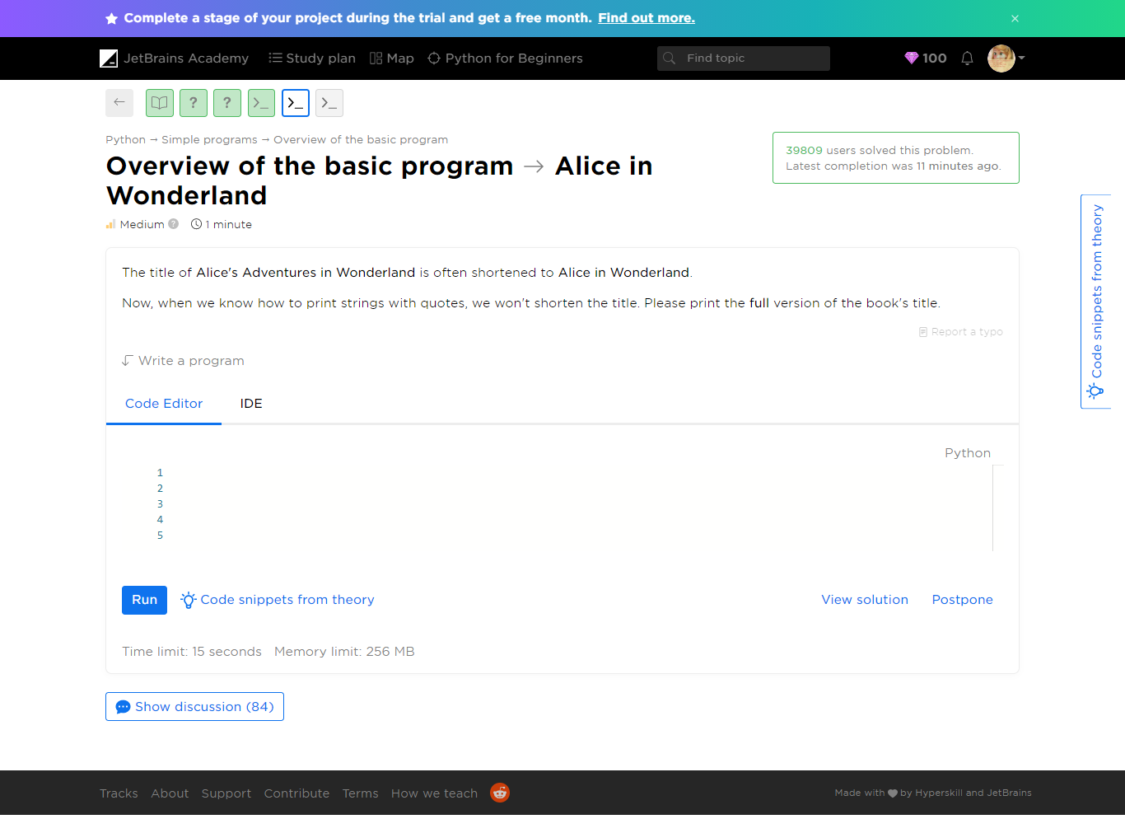

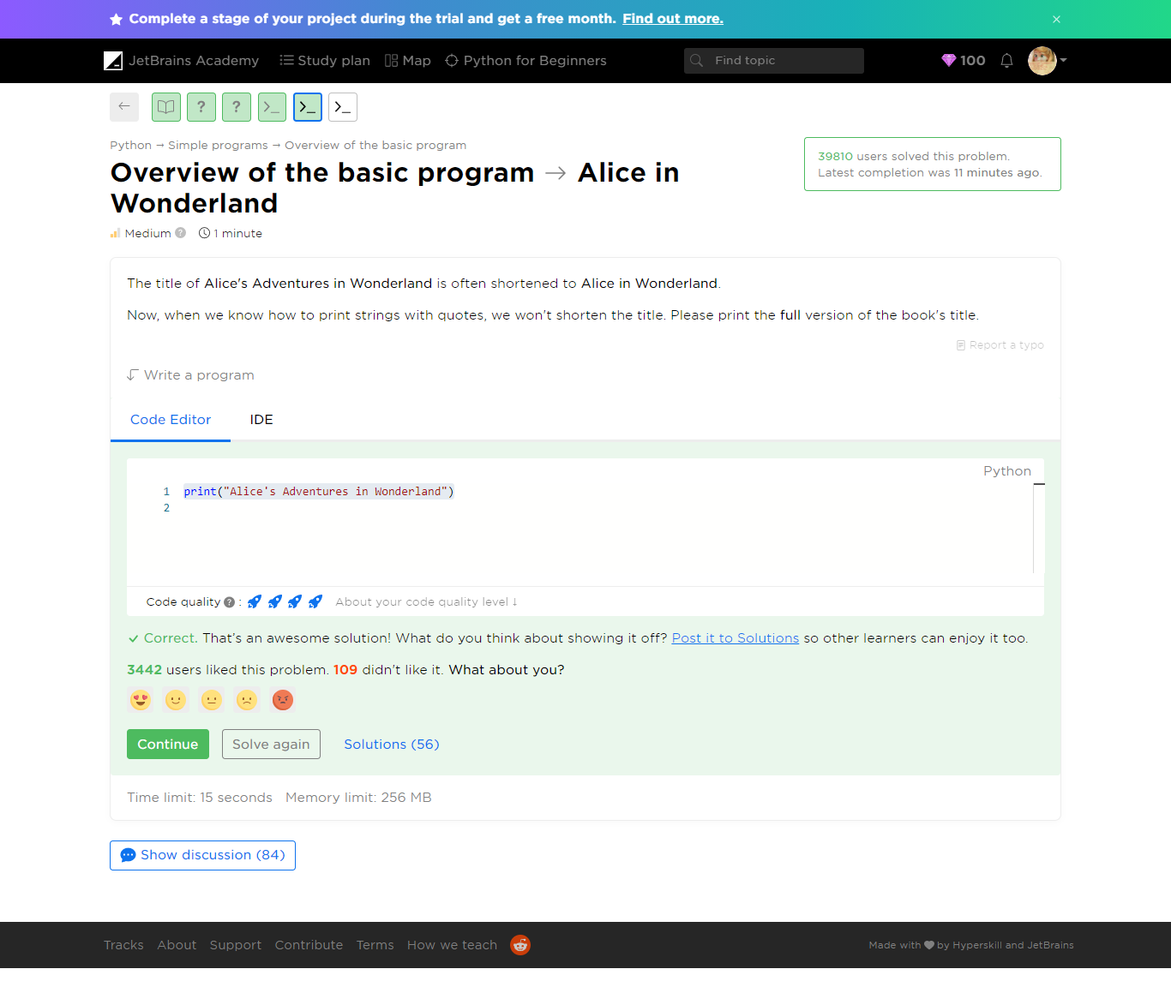

Refer to ***alice-in-wonderland.py***

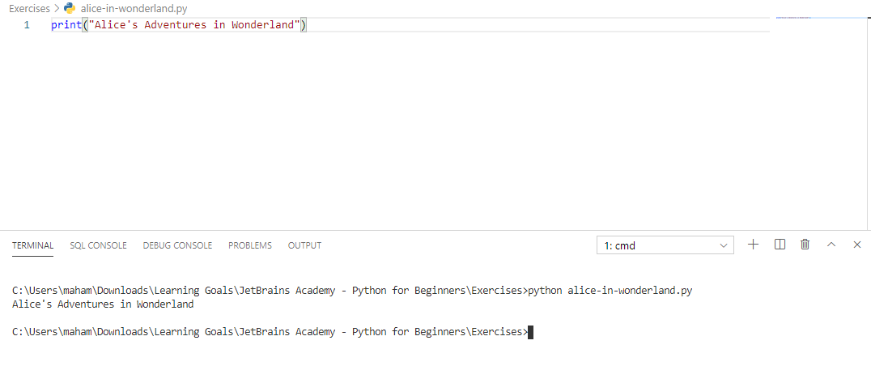

Overview of the basic program -> The eternal truth

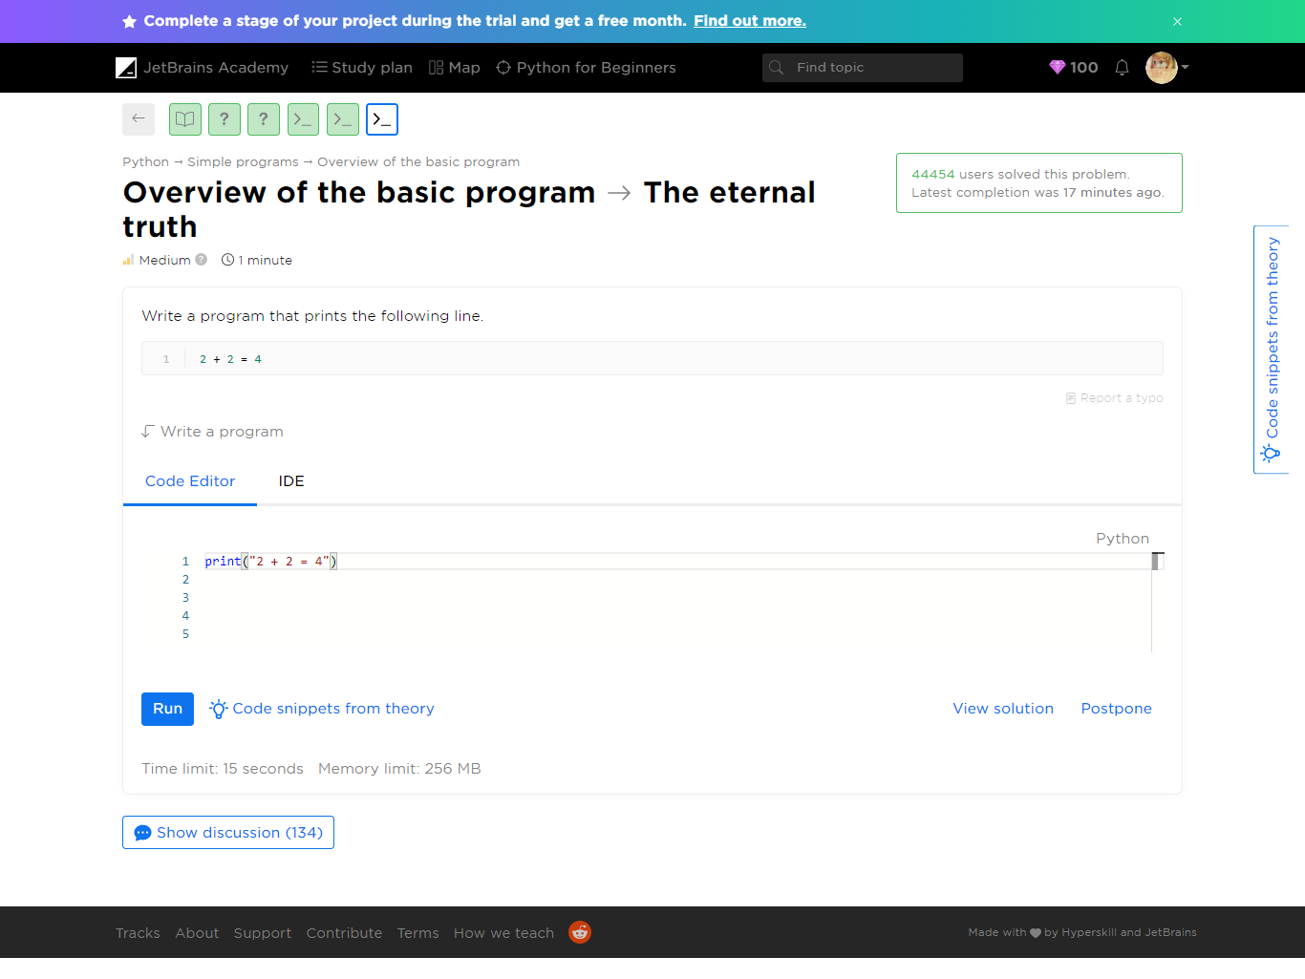

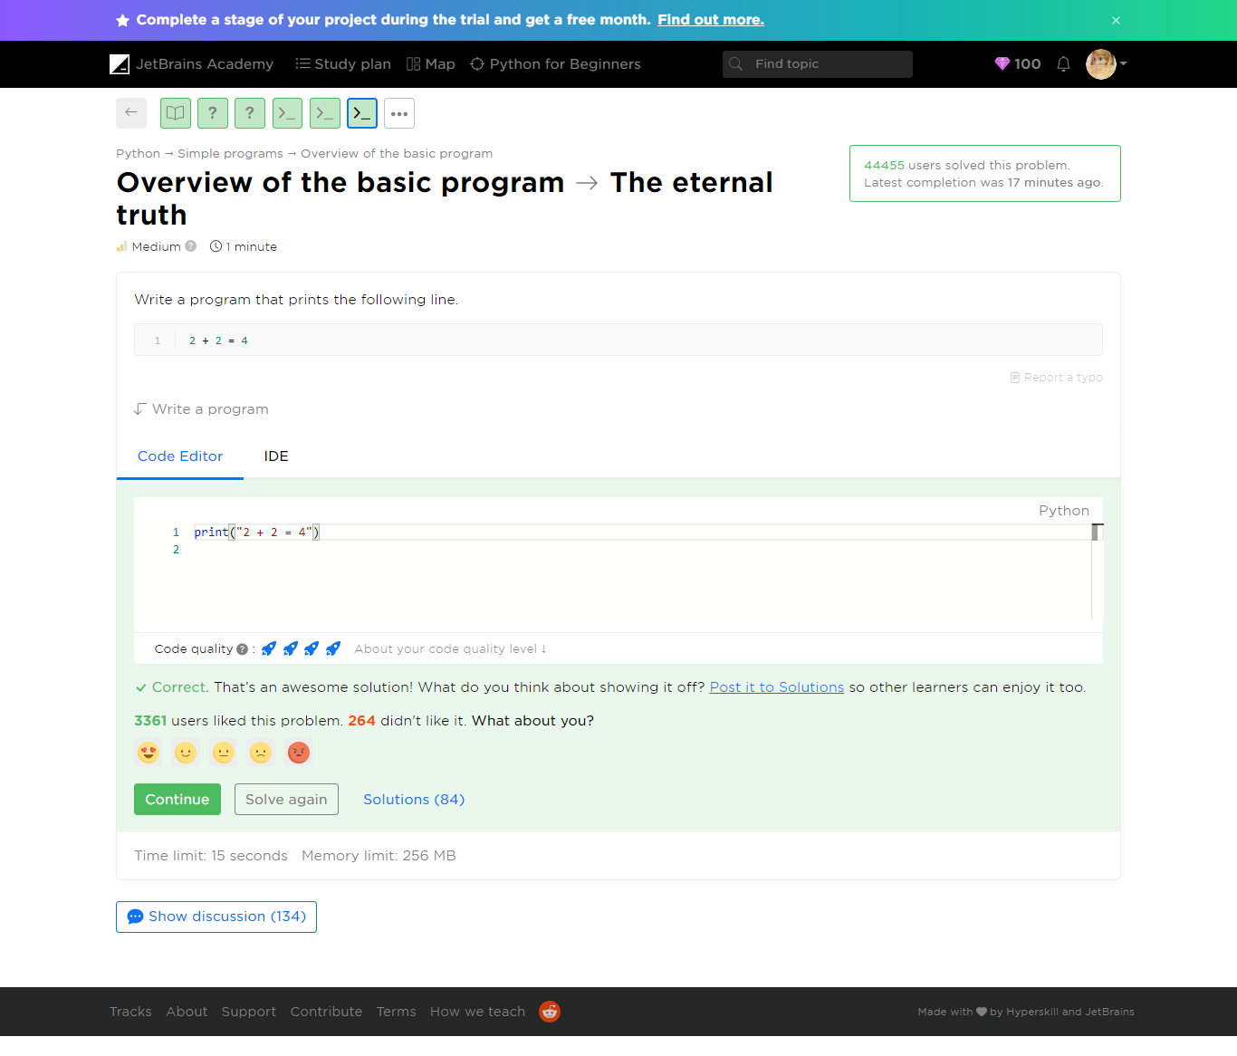

Refer to ***the-eternal-truth.py***

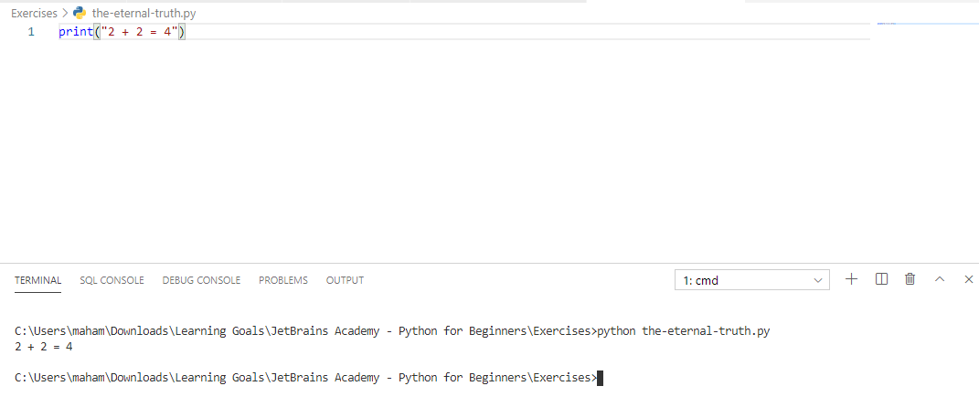

Yaaay!

You completed **Overview of the basic program**

**You solved: 5 problems**

1. Print a text2. Multiple quotes3. Your name

1. The eternal truth2. Alice in Wonderland

**More to solve (optional): 3**

1. Print result2. What is print3. Plain message

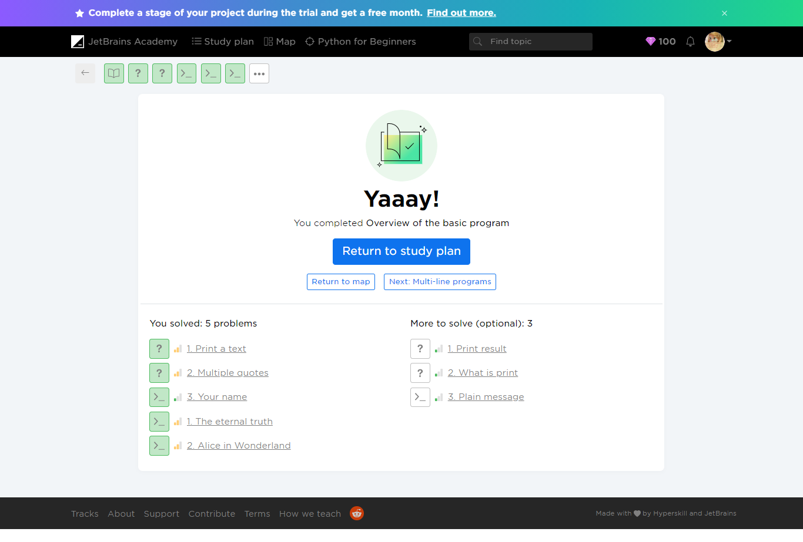

###### Additional Problems

Optional Problems

1. Print result

2. What is print

3. Plain message

Overview of the basic program -> Print result

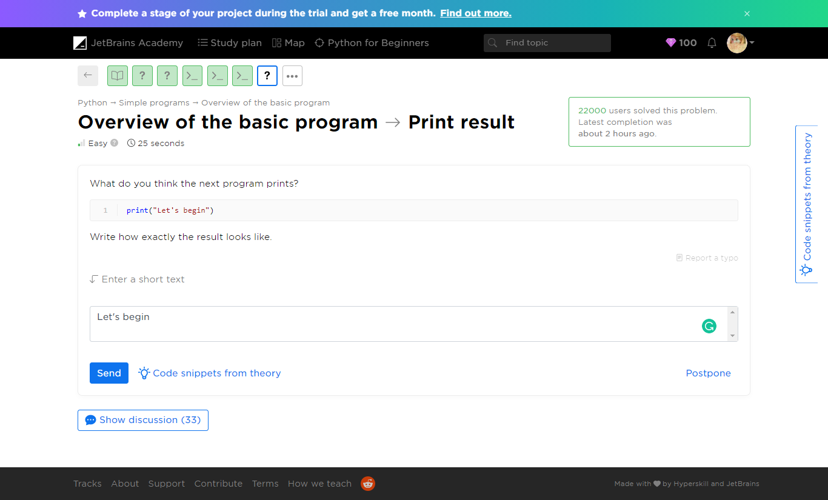

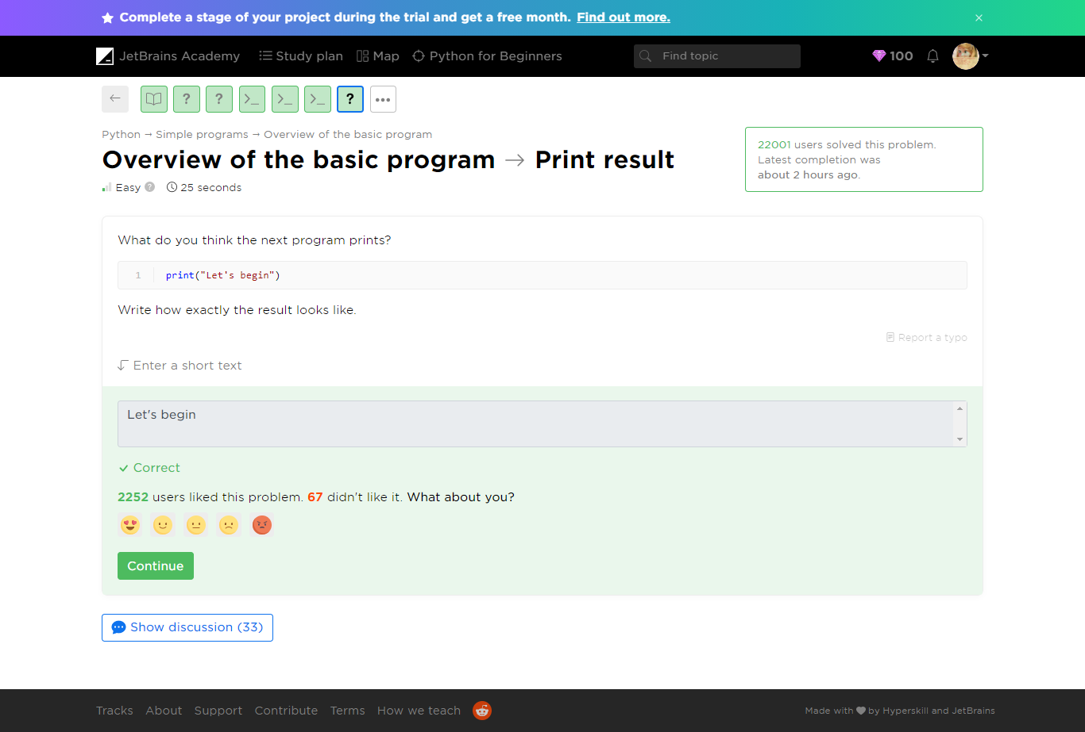

Refer to print-result.py

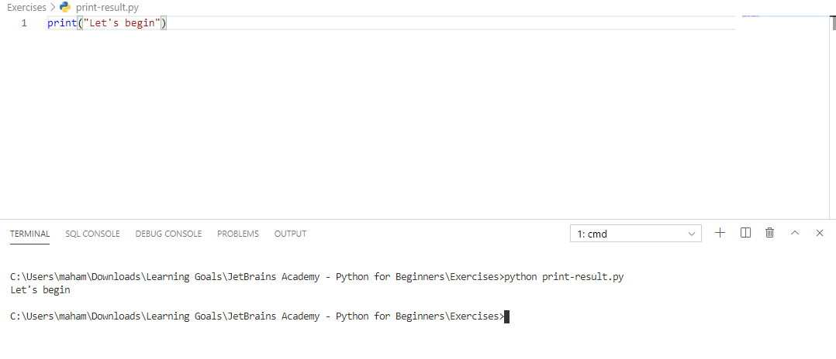

Overview of the basic program -> What is print

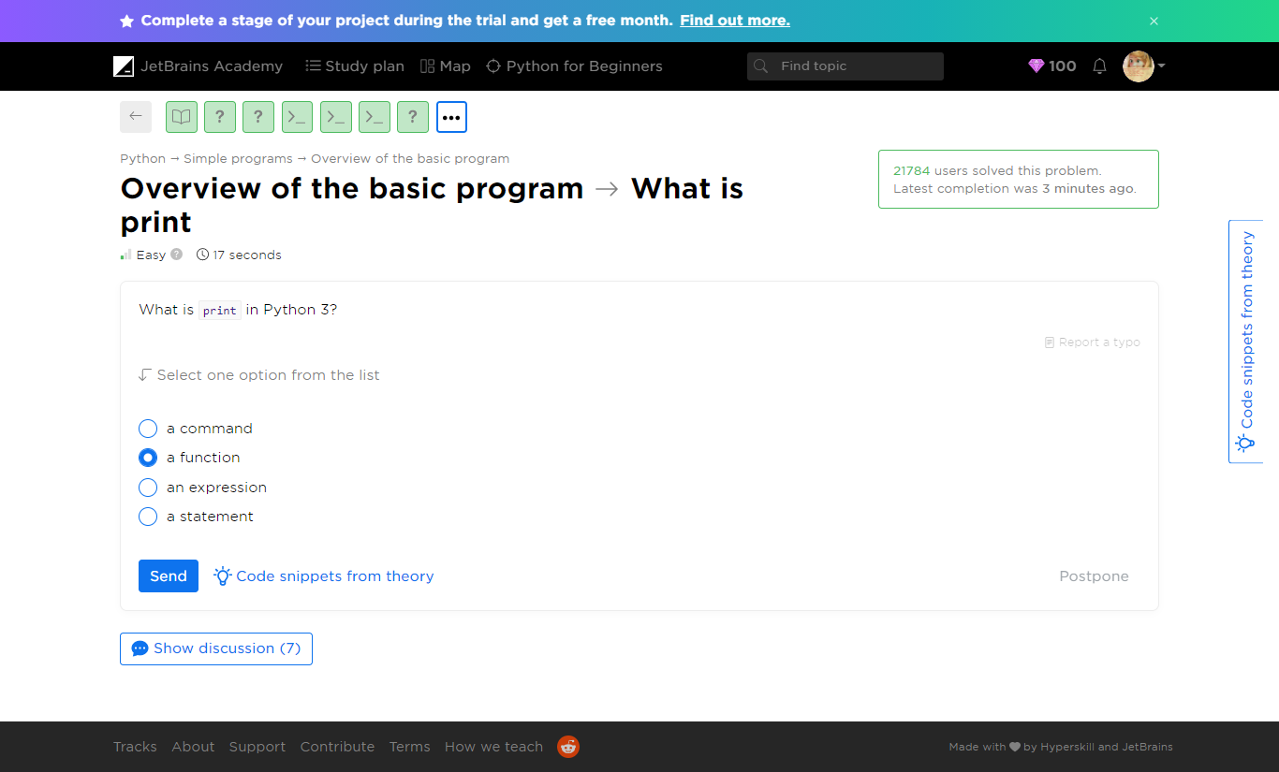

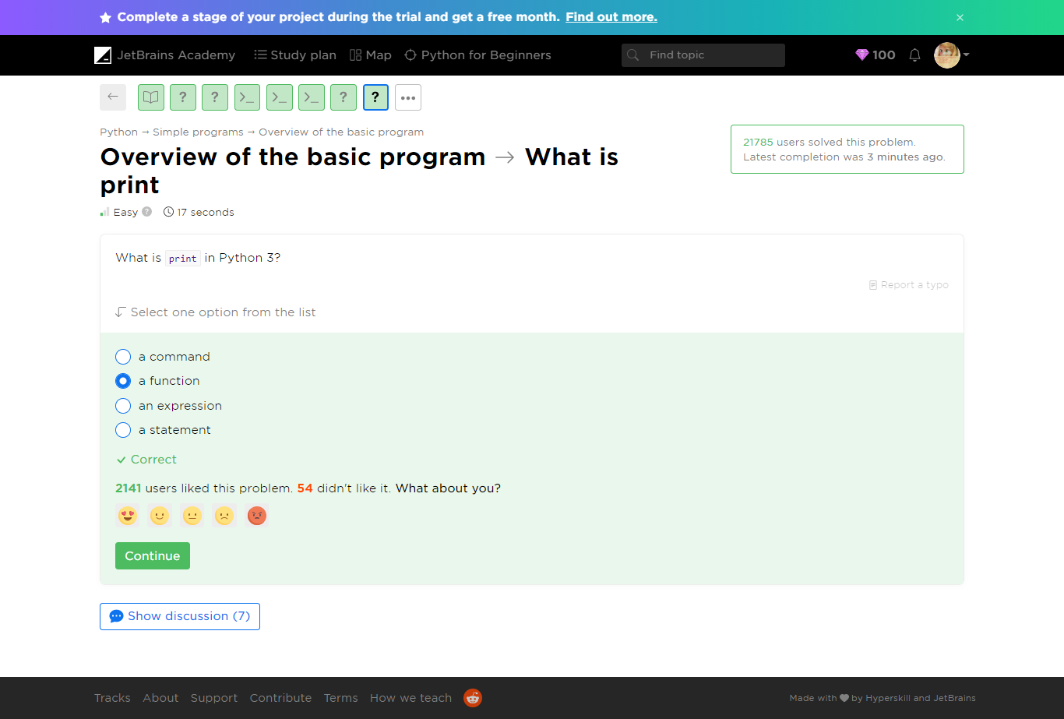

Overview of the basic program -> Plain message

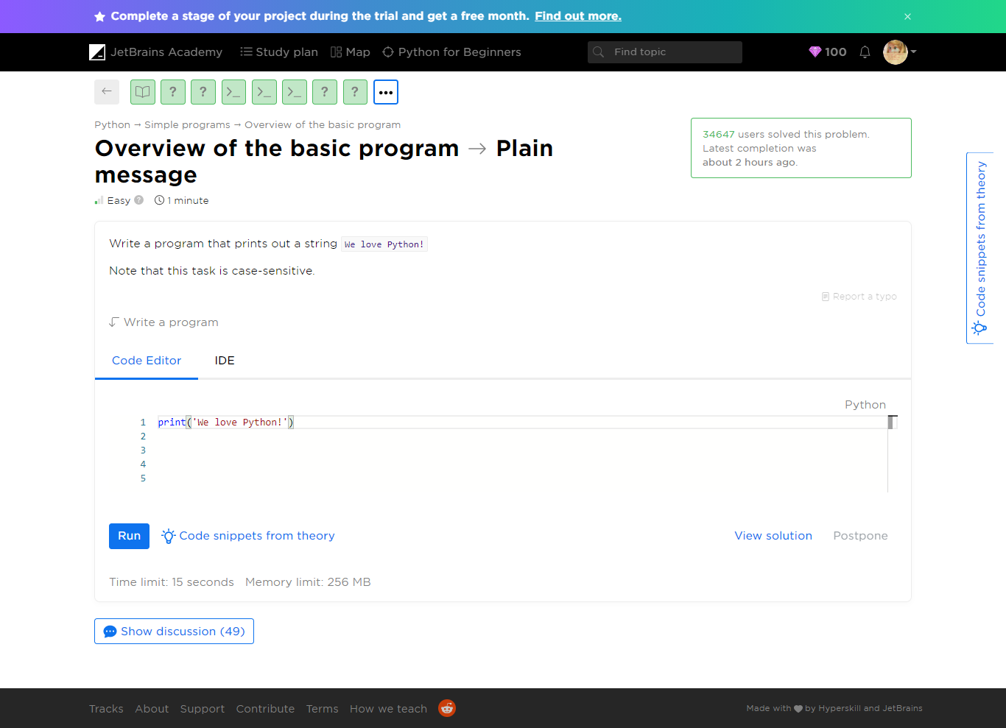

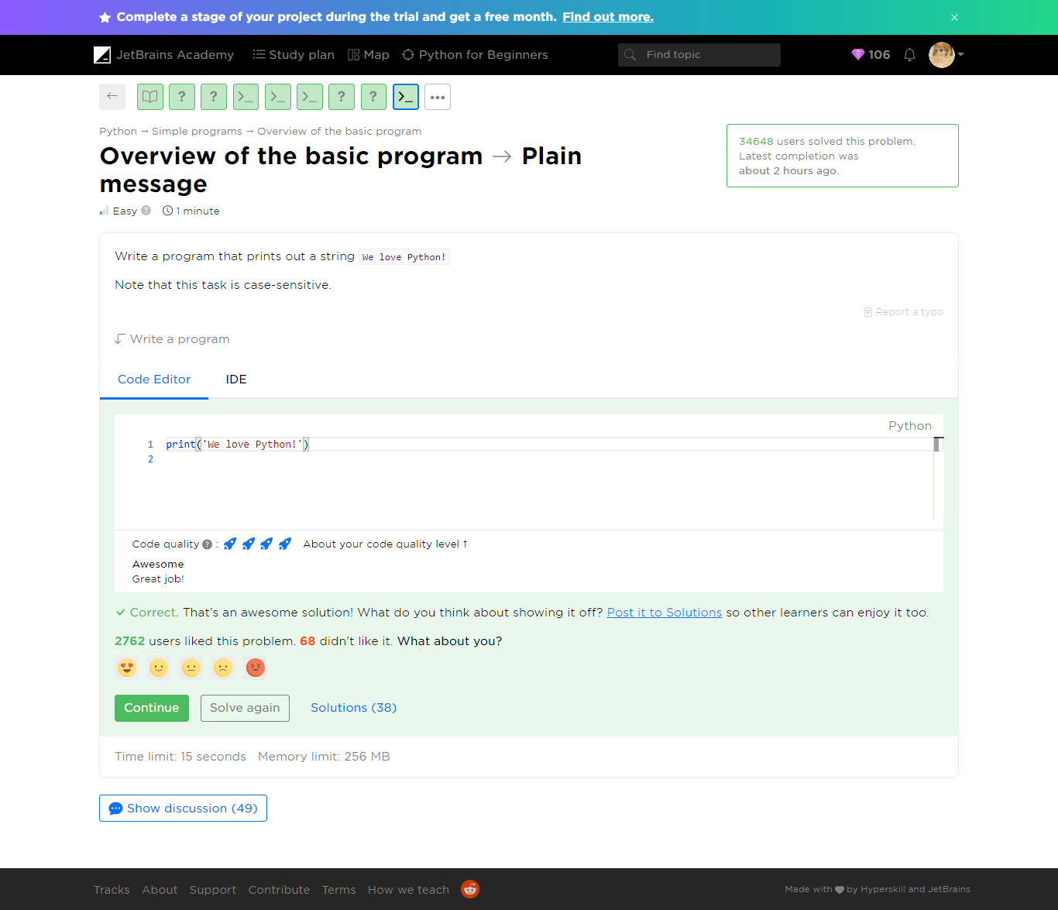

Refer to ***plain-message.py***

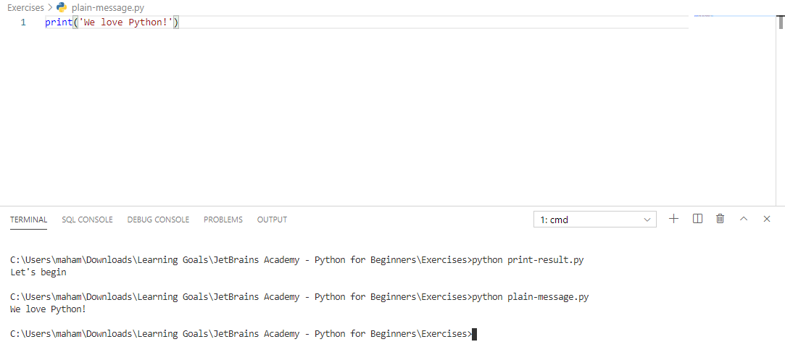

Yaaay!

You completed **Overview of the basic program**

**You solved: 8 problems**

1. Print a text

2. Print result

3. What is print

4. Multiple quotes

5. Your name

1. The eternal truth

2. Alice in Wonderland

3. Plain message

##### Theory: Multi-line programs

 5 minutes 0 / 5 problems solved

We hope you have already learned how to write simple Python programs consisting of a single line that just prints a text. However, real programs contain a significant number of lines: from tens and hundreds for small scripts to thousands and even more for large projects. So, in this lesson, you will write programs that print multiple lines.

Let's consider an example, the following code prints exactly three strings, each on a new line:

print("I")  
print("know")  
print("Python")

The output is:

I  
know  
Python

You can run this example [here](https://repl.it/languages/python3) or locally if you have already installed Python on your computer.

There are other ways to print the same text using just one function call. We will consider them in the next topics.

The print function also allows you to print an empty line with no string specified:

print("I")  
print()  
print("know")  
print()  
print("Python")

Here's the output:

I  
  
know  
  
Python

However, skipping the line will have no effect:

print("And")  
  
print("you?")

The output is:

And  
you?

Now it's time to solve some problems.

**Current topic:**

[Multi-line programs Stage 1](https://hyperskill.org/learn/step/5233" \t "_self)

**Topic depends on**

[Overview of the basic program Stage 1](https://hyperskill.org/learn/step/5208" \t "_self)

**Topic is required for**

Program execution

[Comments Stage 2](https://hyperskill.org/learn/step/6081" \t "_self)

**Table of contents:**

[↑ Multi-line programs](https://hyperskill.org/learn/step/5233#step-title)

###### Multi-line programs -> Nuances

 Easy  25 seconds

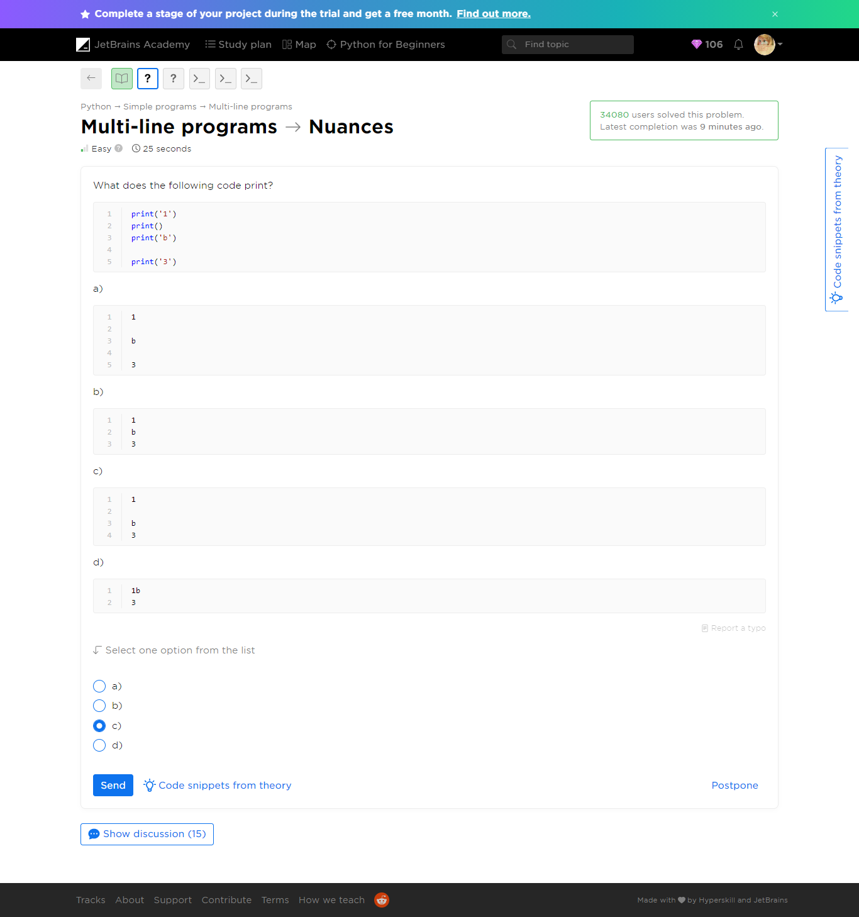

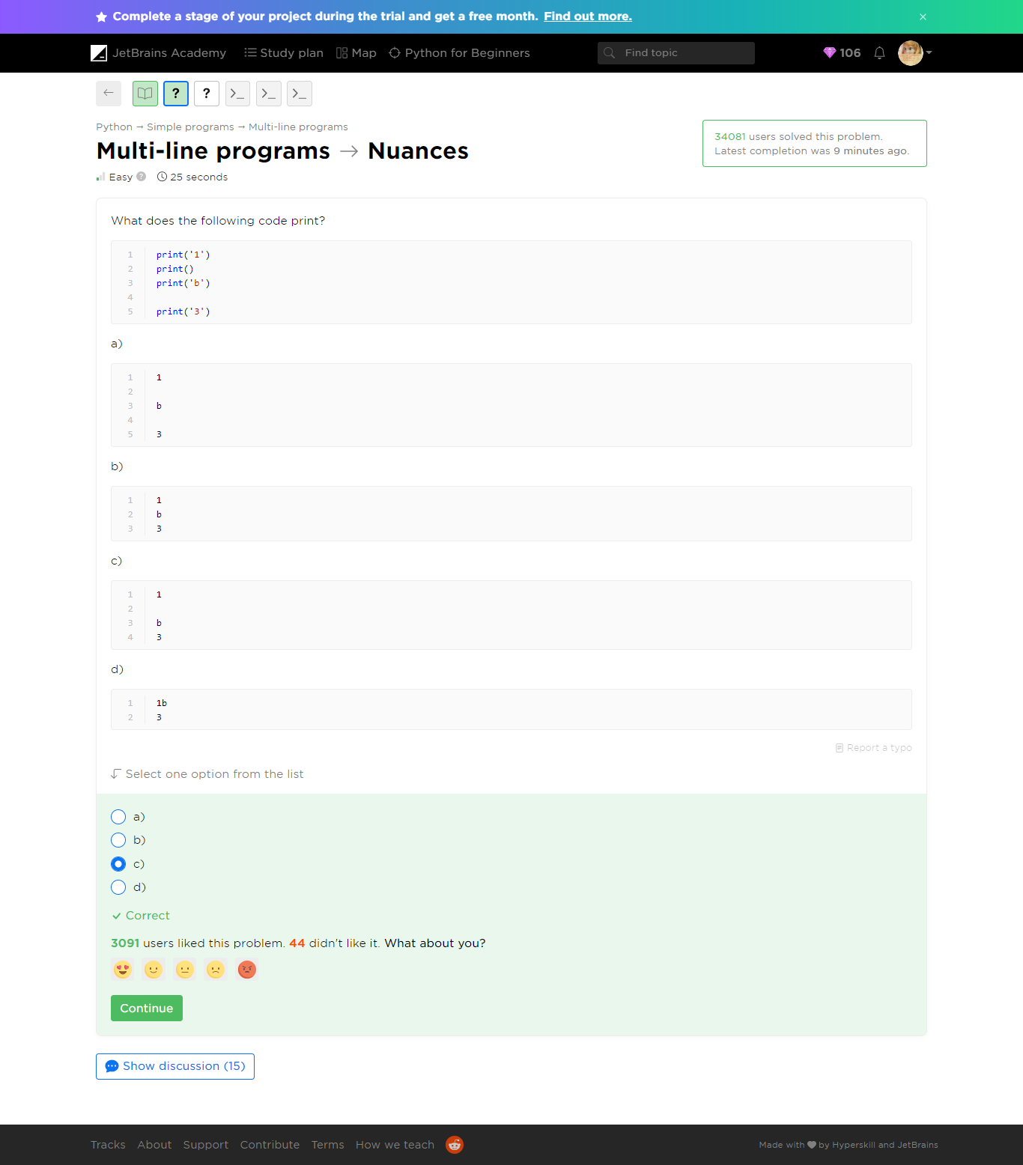

Refer to ***nuances.py***

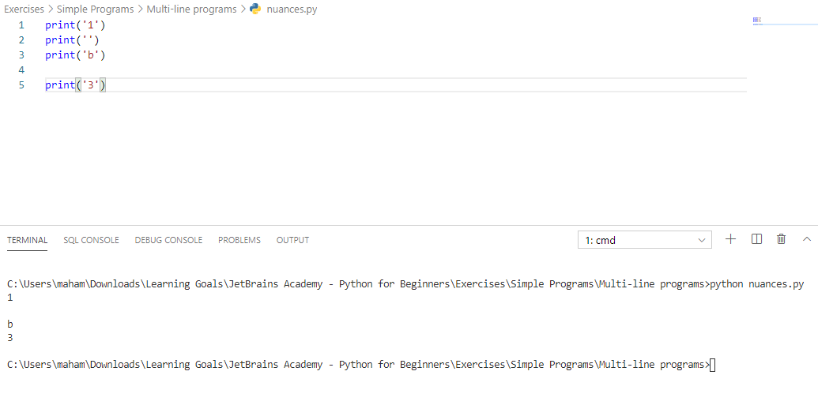

###### [Multi-line programs](https://hyperskill.org/learn/step/5233)-> Count the empty

 Medium  25 seconds

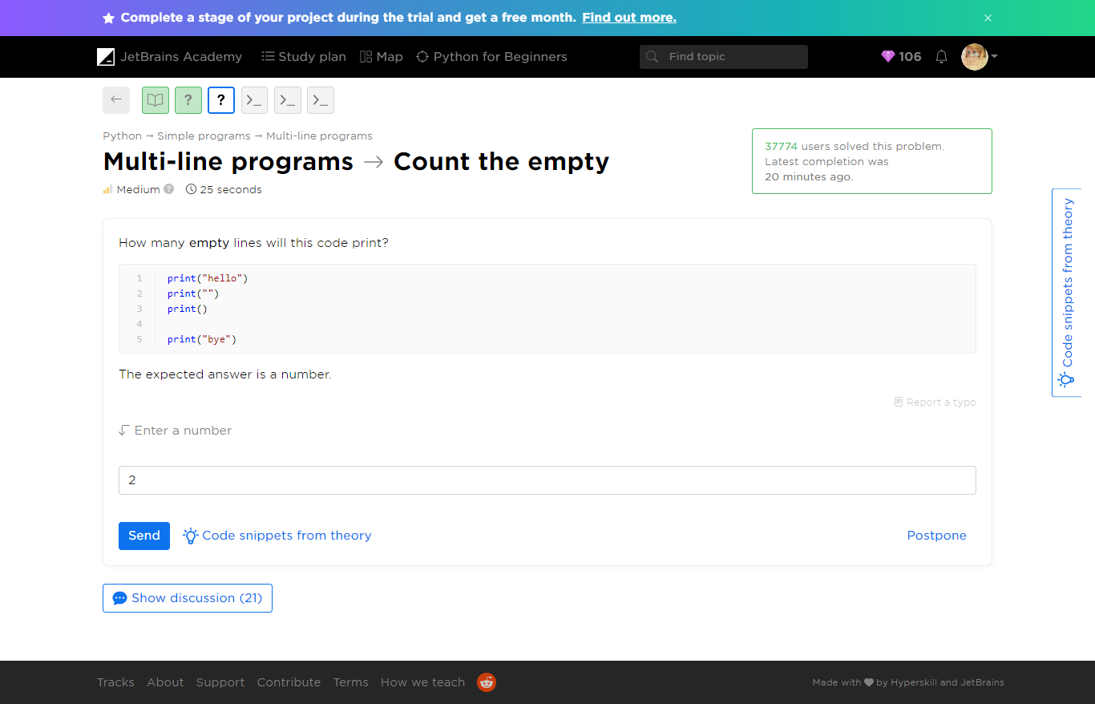

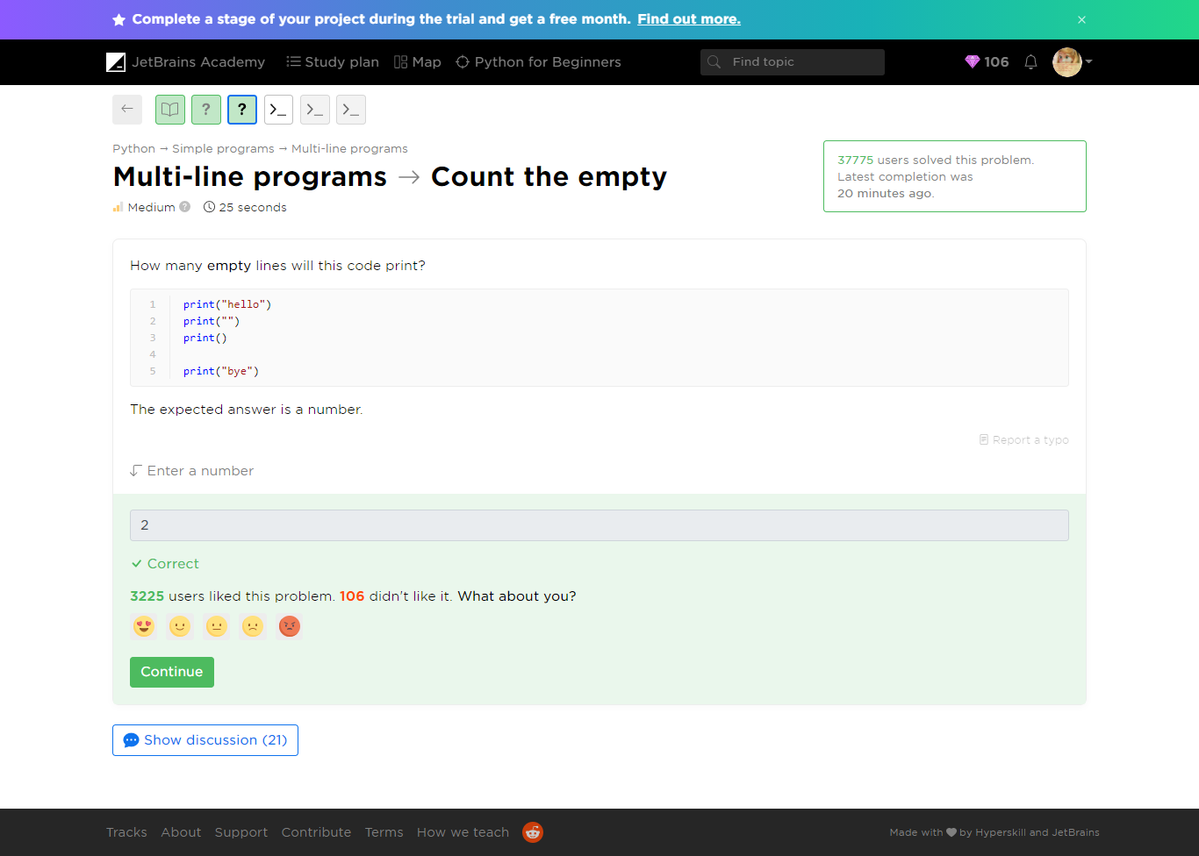

Refer to ***count-the-empty.py***

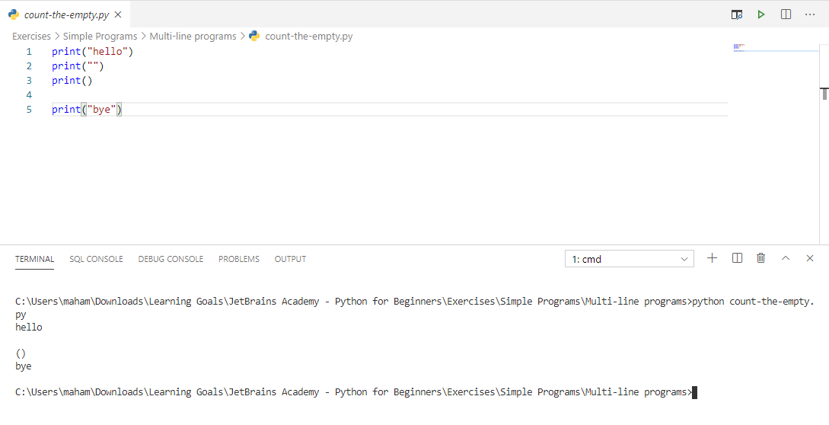

###### [Multi-line programs](https://hyperskill.org/learn/step/5233) -> The result of a game in Tic-Tac-Toe

 Medium  1 minute

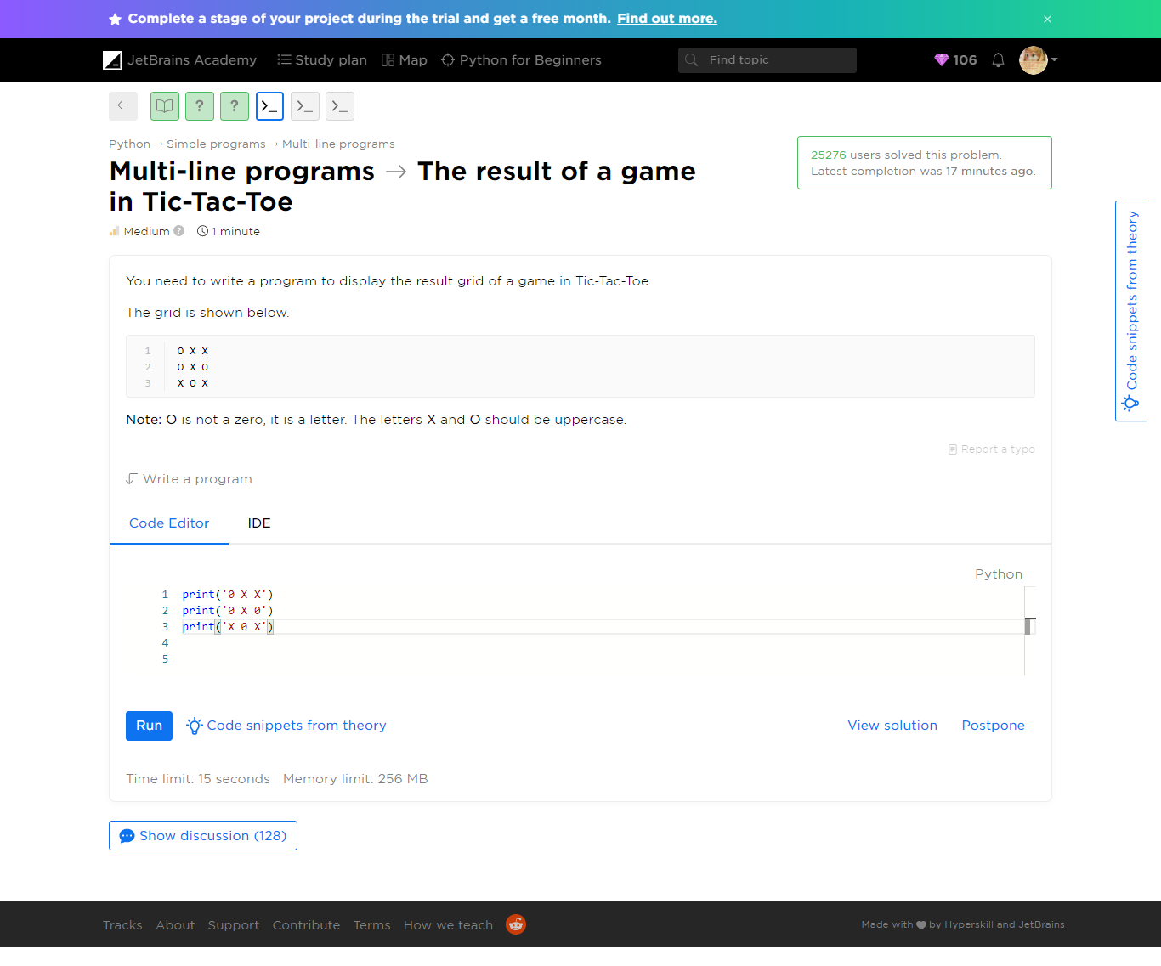

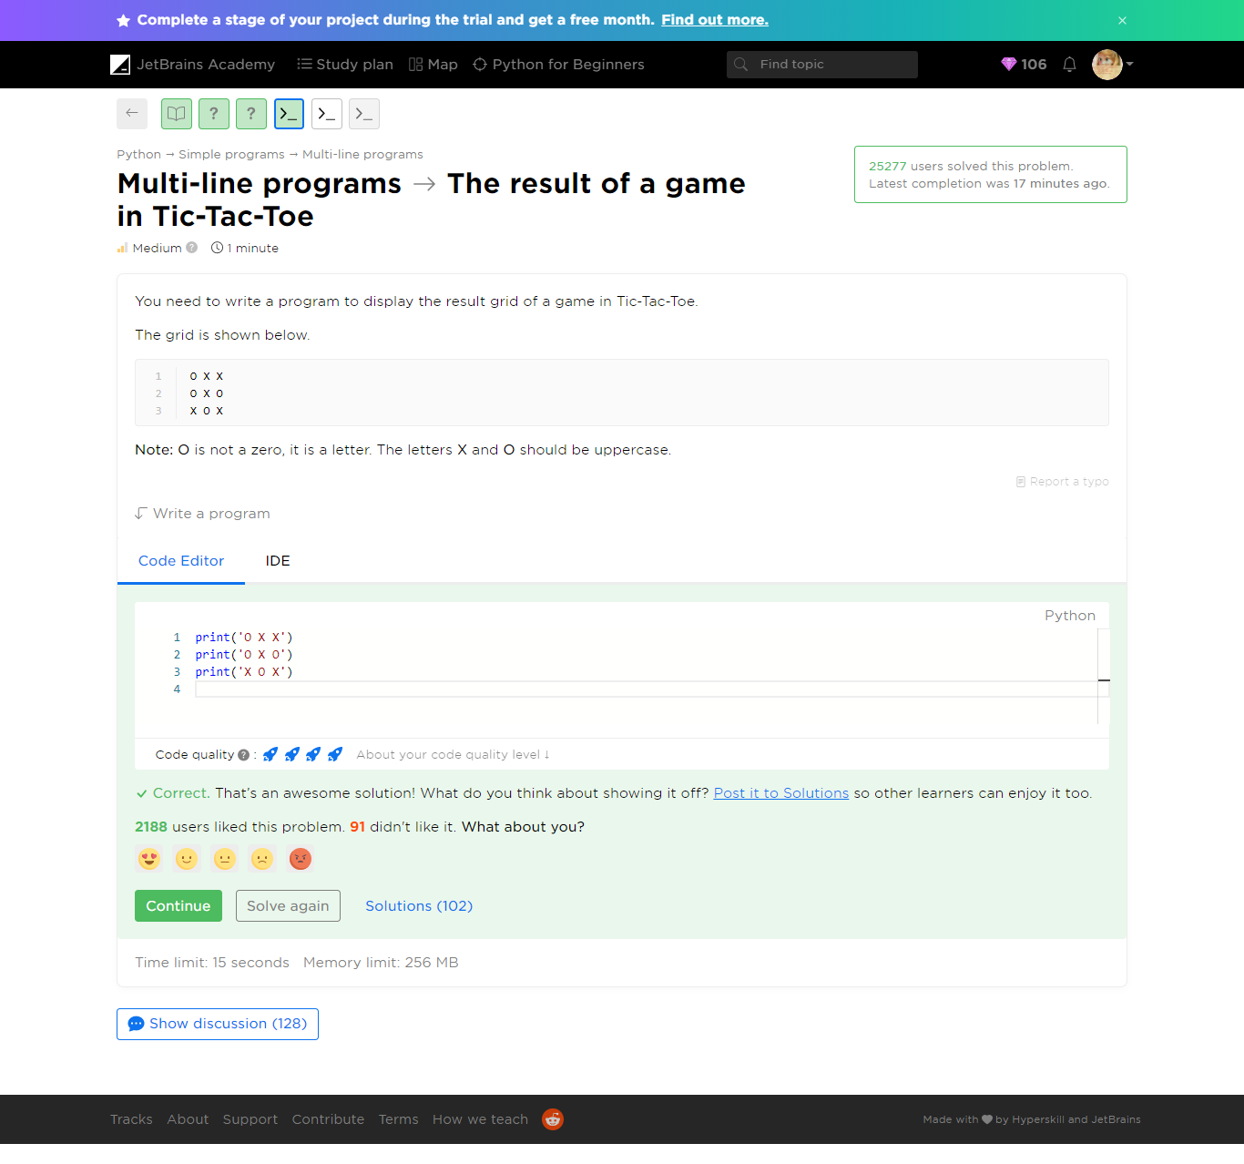

Refer to ***result-of-tic-tac-toe.py***

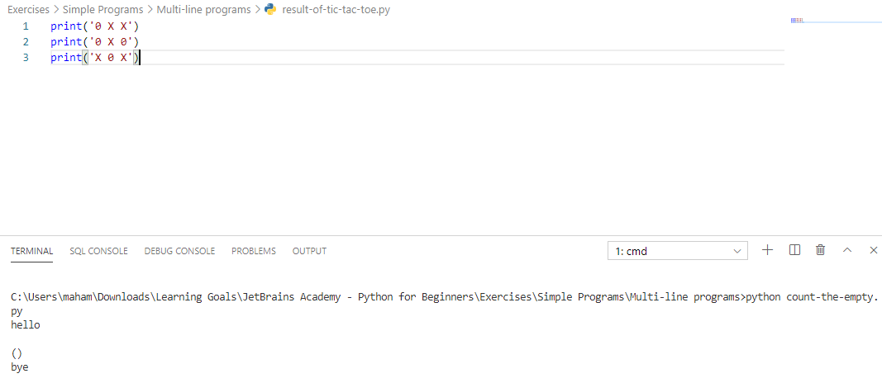

###### [Multi-line programs](https://hyperskill.org/learn/step/5233) -> First, second, third

 Easy  1 minute

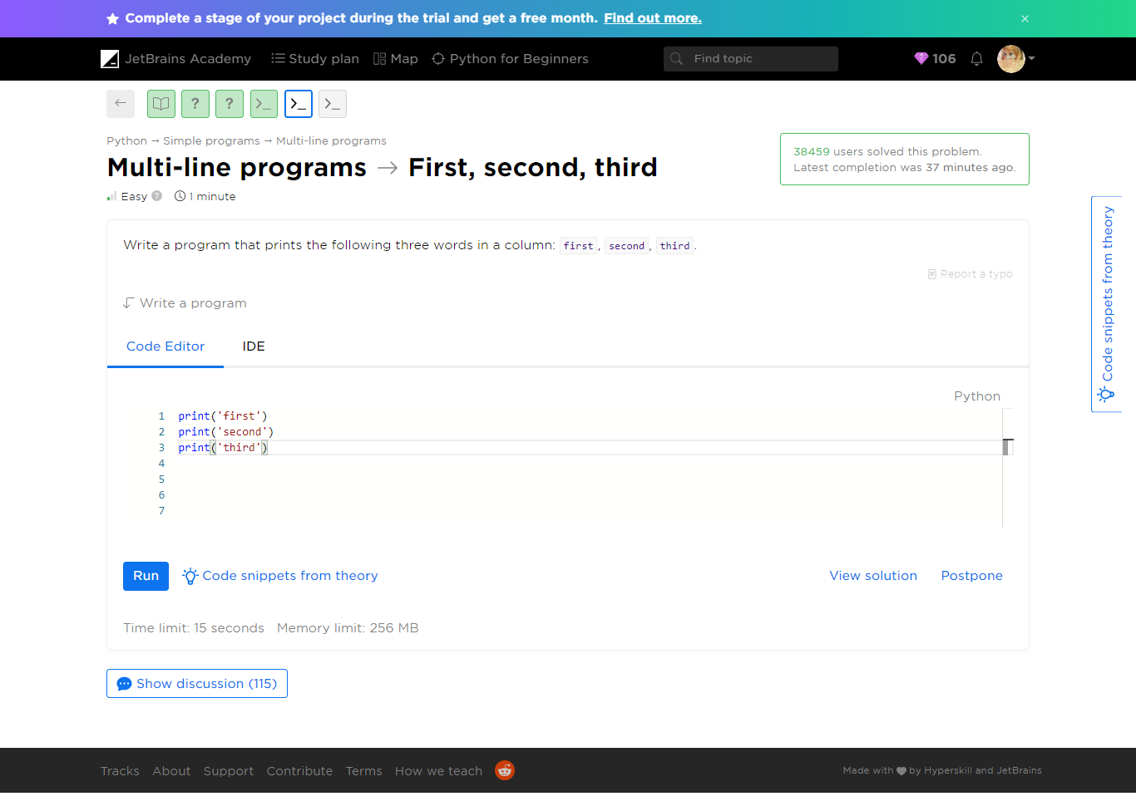

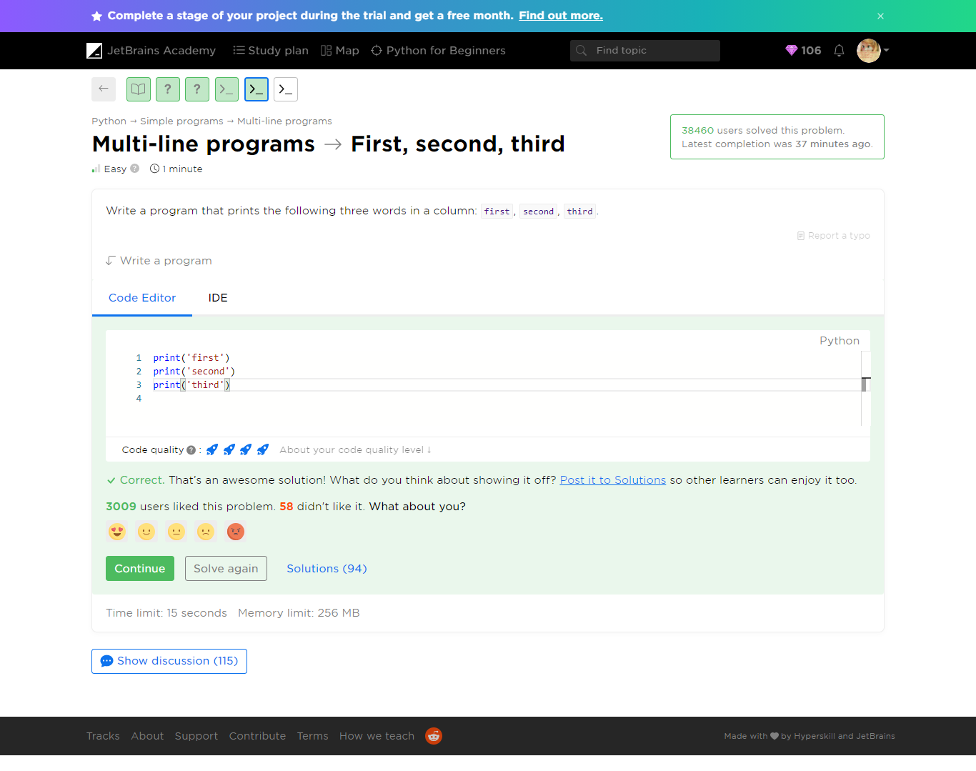

Refer to ***first-second-third.py***

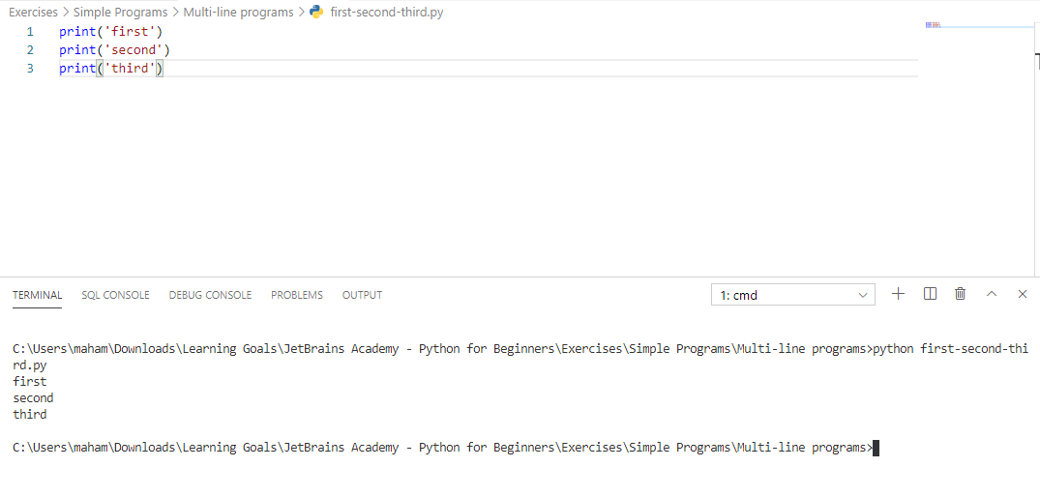

###### [Multi-line programs](https://hyperskill.org/learn/step/5233) -> We need learn Python

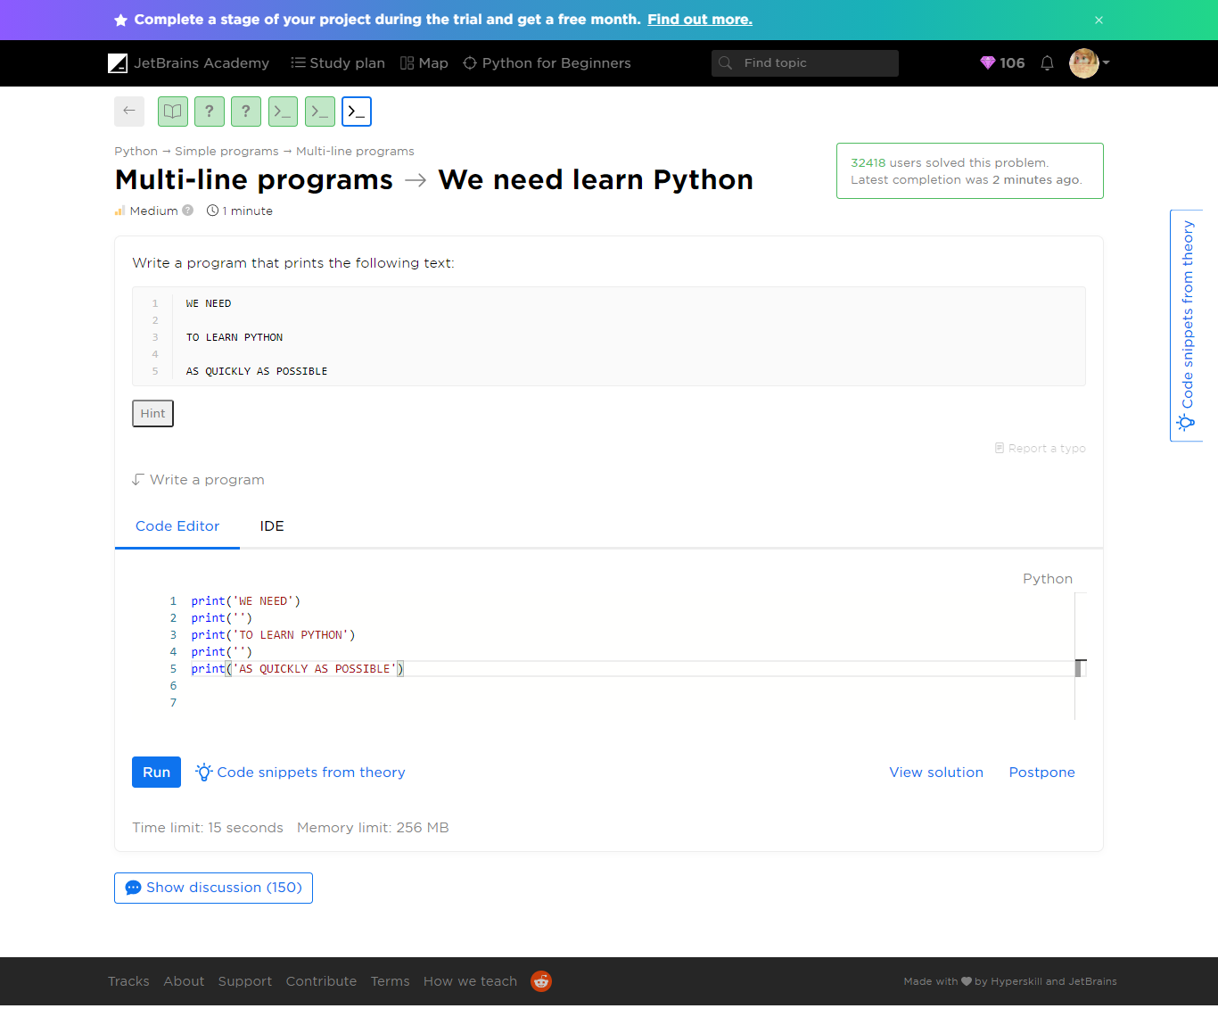

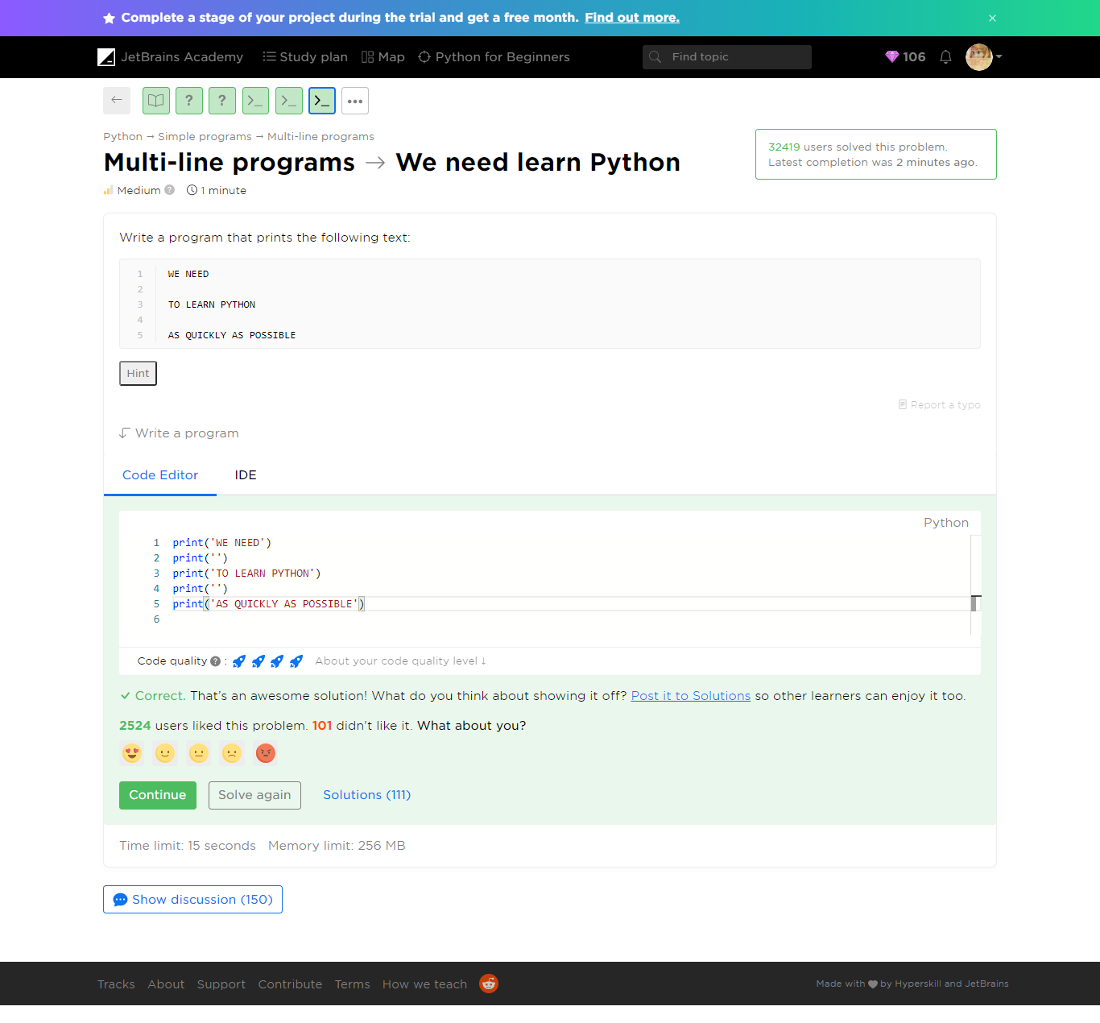

Refer to we-need-learn-python.py

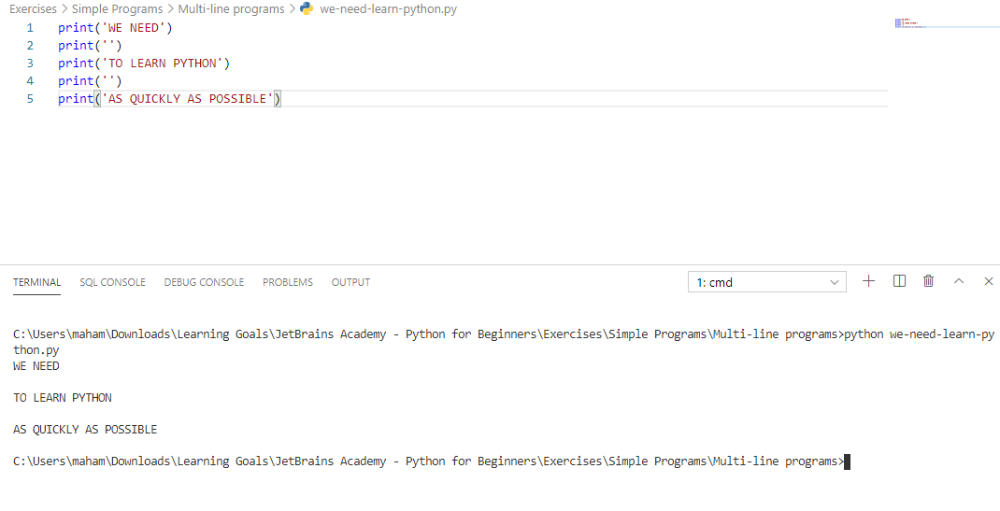

Yaaay!

You completed **Multi-line programs**

**You solved: 5 problems**

1. Count the empty

2. Nuances

3. We need learn Python

1. First, second, third

2. The result of a game in Tic-Tac-Toe

**More to solve (optional): 2**

1. Lines

2. Square

###### Additional Problems

Multi-line programs -> Lines

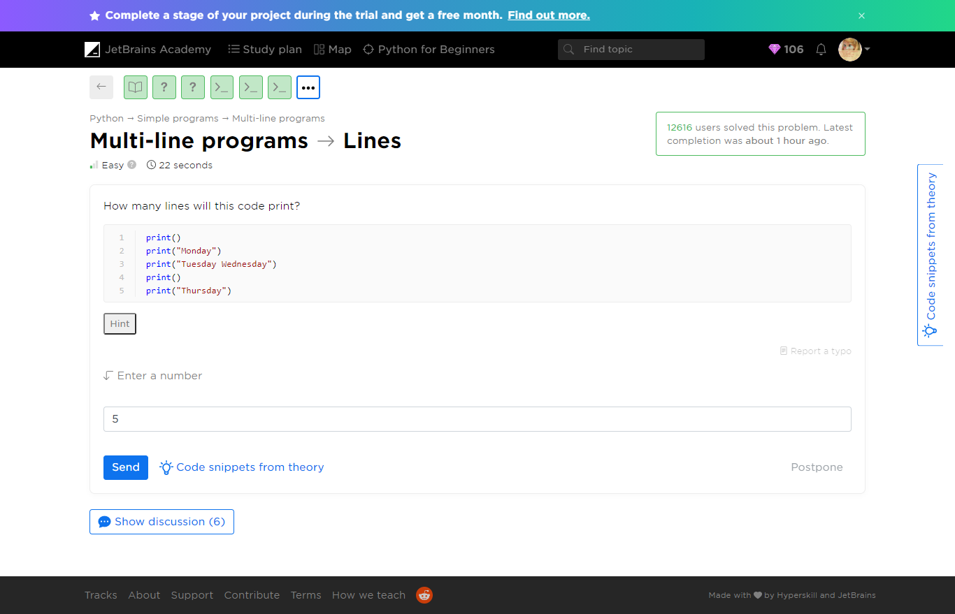

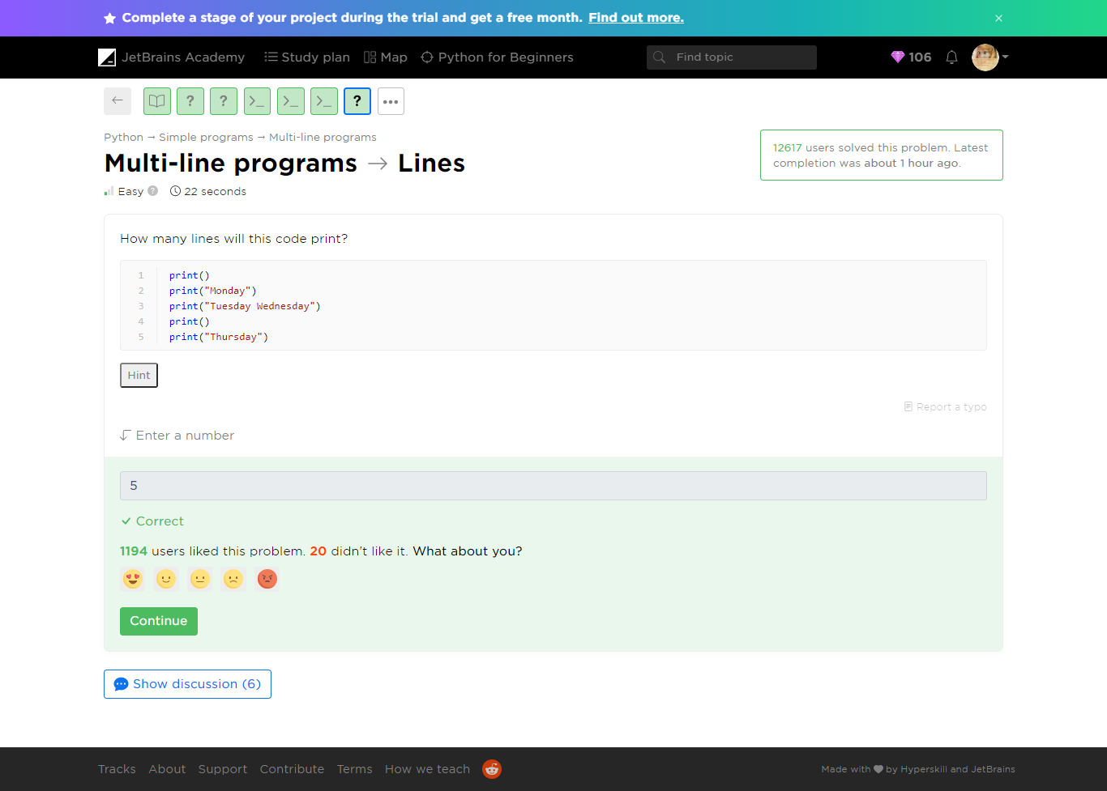

Refer to lines.py

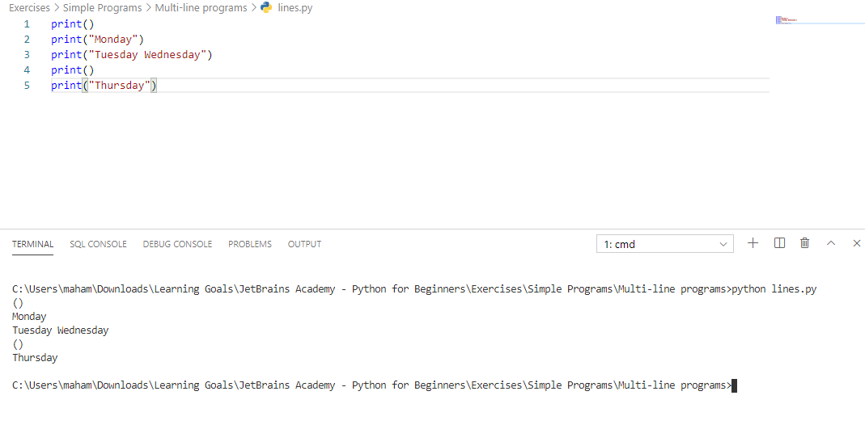

[Multi-line programs](https://hyperskill.org/learn/step/5233) ->Square

 Medium  2 minutes

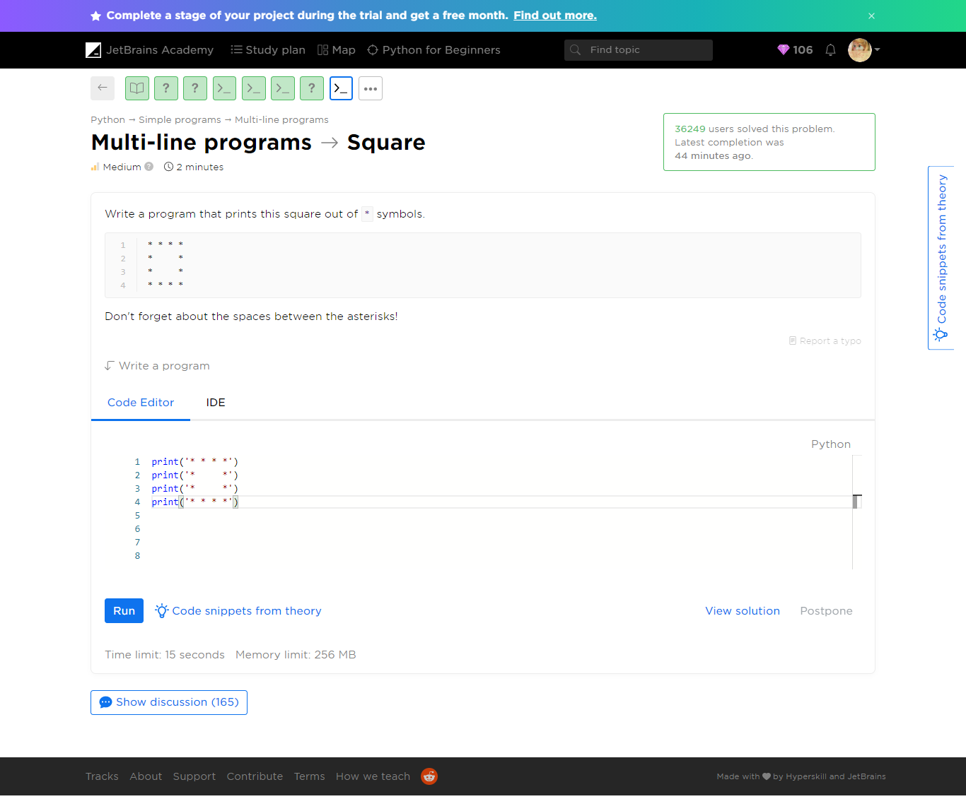

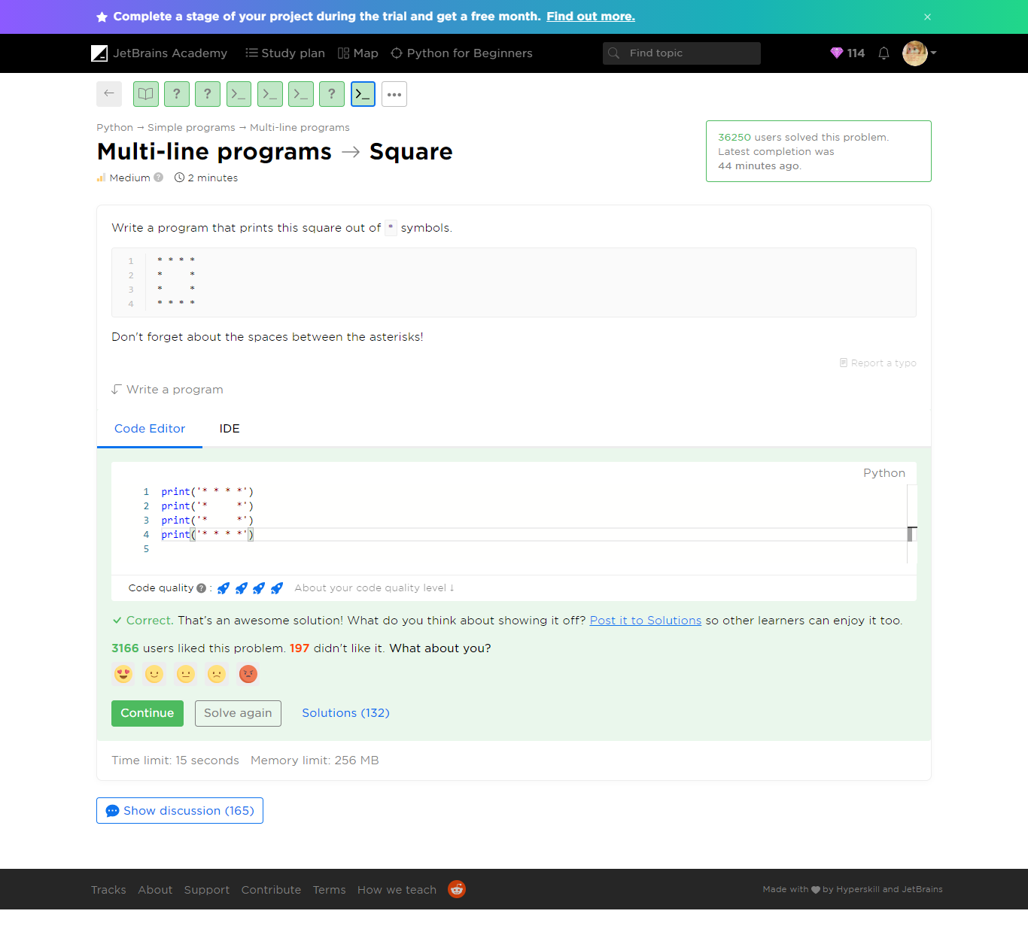

Refer to square.py

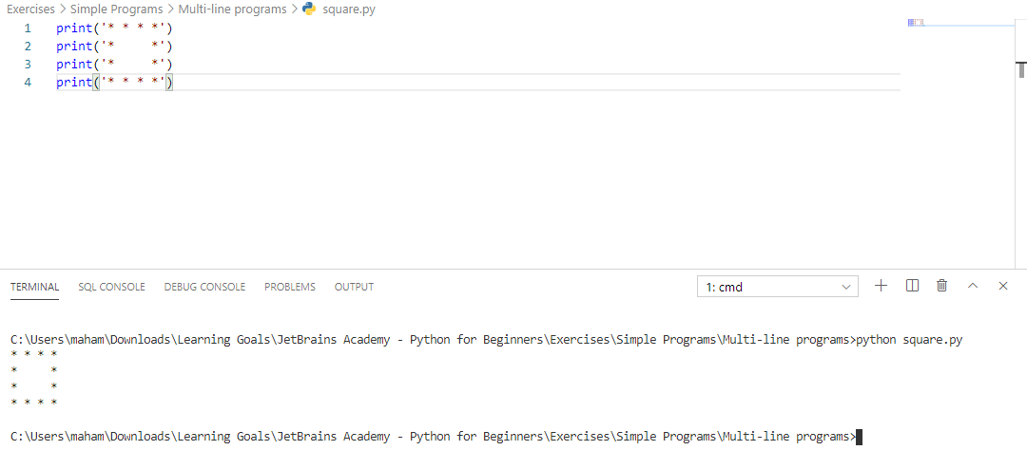

Yaaay!

You completed **Multi-line programs**

**You solved: 7 problems**

1. Count the empty

2. Lines

3. Nuances

4. We need learn Python

1. First, second, third

2. The result of a game in Tic-Tac-Toe

3. Square

##### Tell us about your level and goals

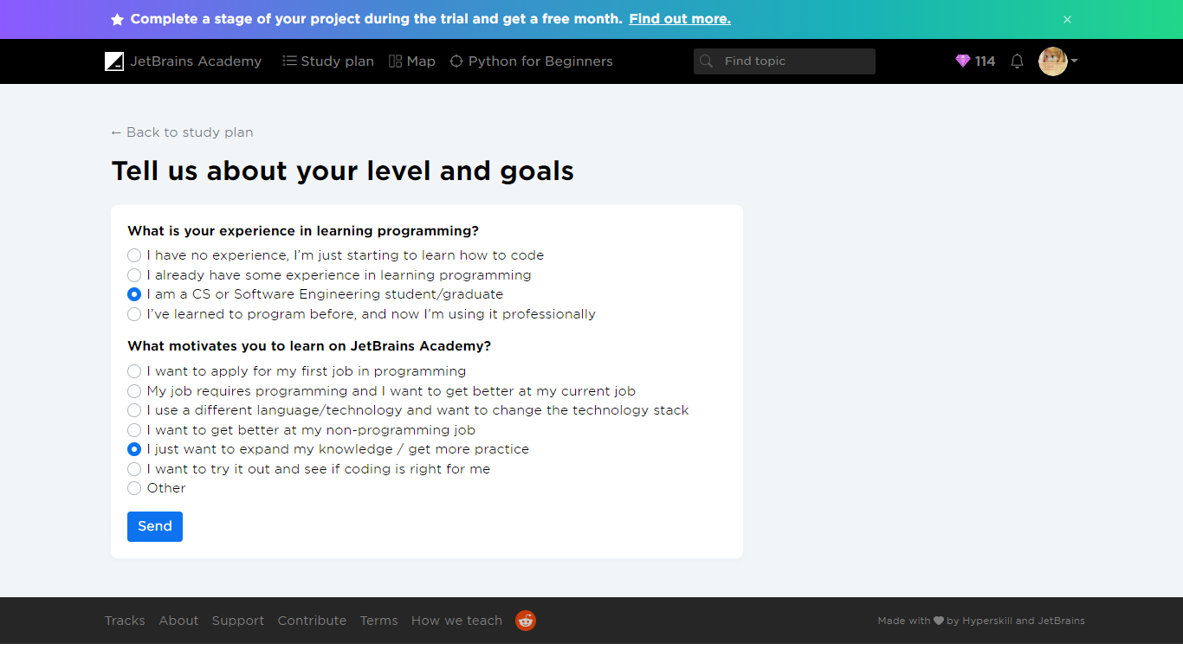

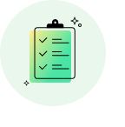

Survey completed!

**+  25 gems**

We appreciate your opinion!

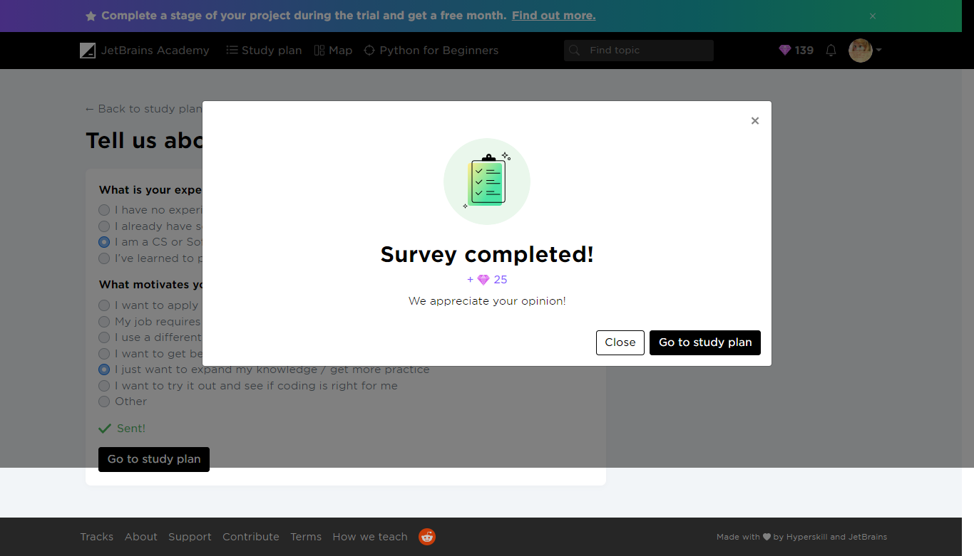

##### Work on project. Stage 1/4: Rush into print.

Project: [Zookeeper](https://hyperskill.org/projects/98)

 Medium  2 minutes

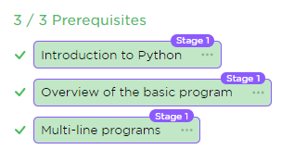

###### Description

There are many animals in the zoo, and all of them need care. The animals must be fed, cleaned, surrounded by their kin, and kept happy. That is a difficult task for our large zoo, so one of your employers has suggested a more convenient way to keep track of everything. She wants to be able to pull up a video feed of any animal in the zoo with the help of a program. Being able to check on each habitat would help the zookeepers take care of our furry friends more efficiently!

In this project, you will create a program that helps the zookeepers check on the animals and make sure that they're doing well. Your product will be able to process commands from the zookeepers and display the animals on a monitor.

###### Objectives

To begin with, you will develop a simple printer. Your program should display the text from the output example.

###### Example

Output

I love animals!  
Let's check on the animals...  
The deer looks fine.  
The bat looks happy.  
The lion looks healthy.

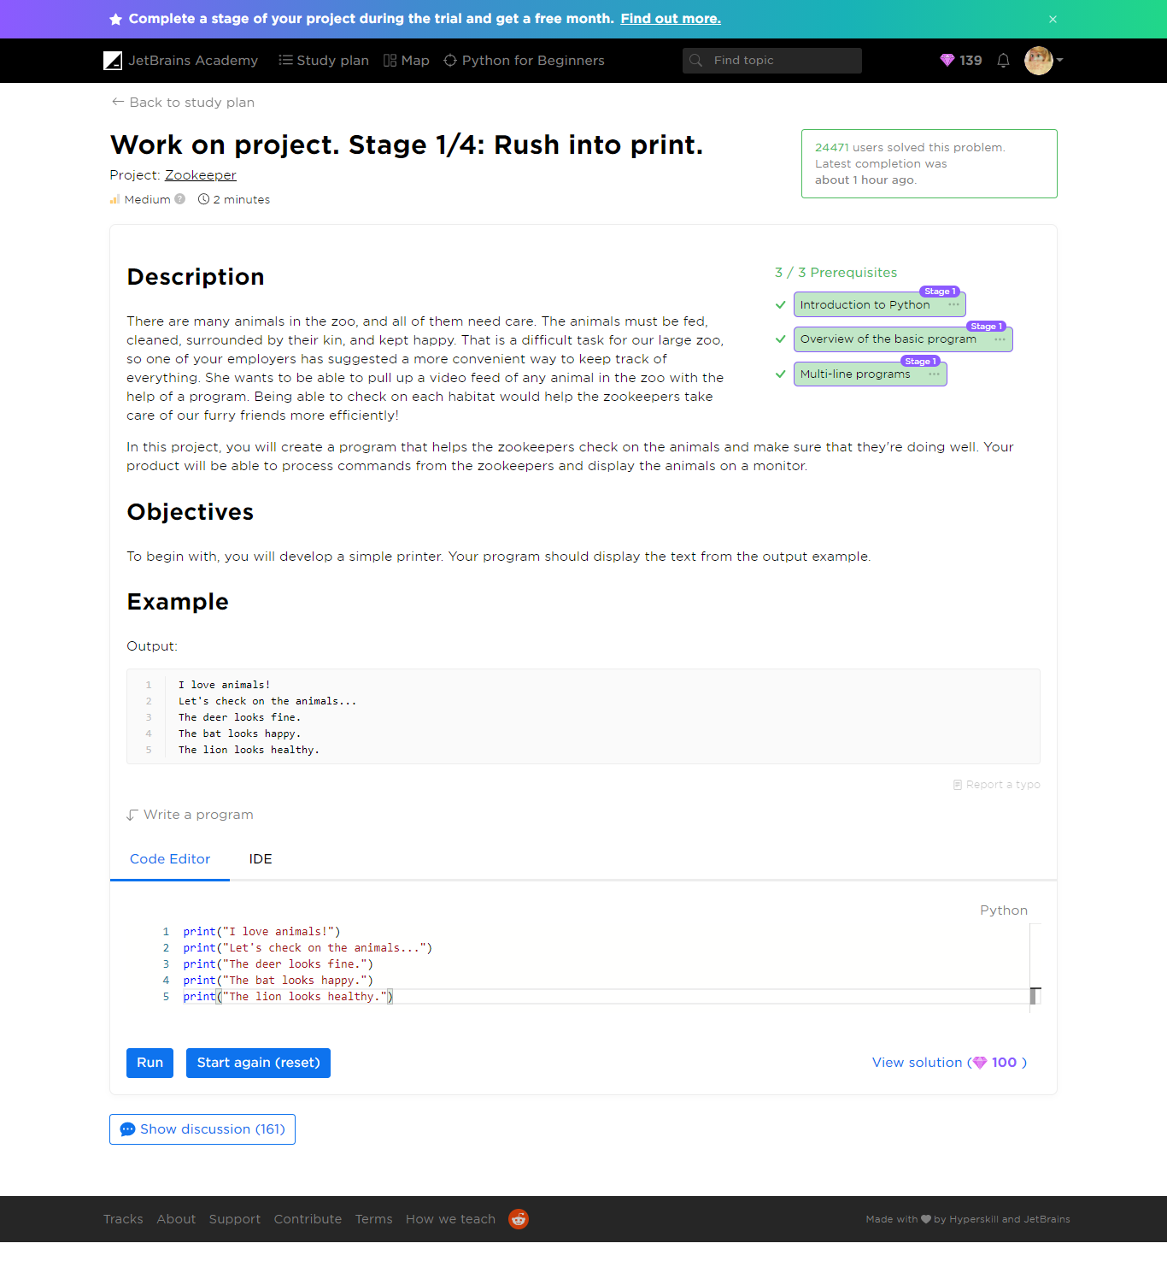

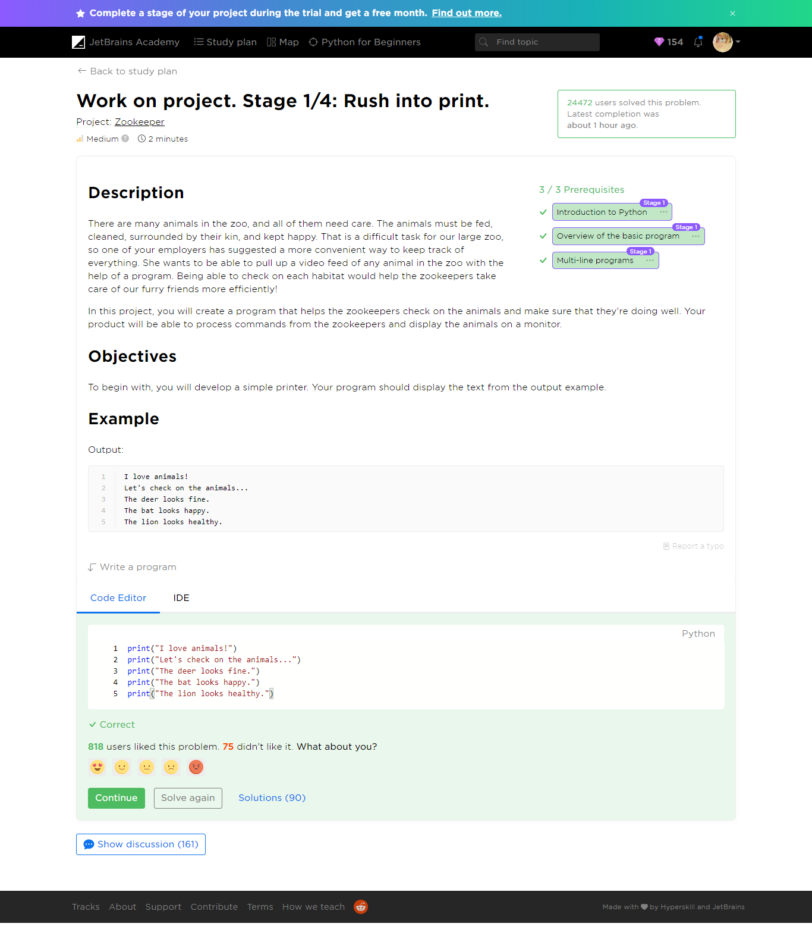

Yay! You've completed Stage 1/4!

Keep on learning and soon you'll complete your project.

**+  15gems**

for completing the stage

#### Congratulations!

FREE MONTH

Your trial is extended by 31 days!

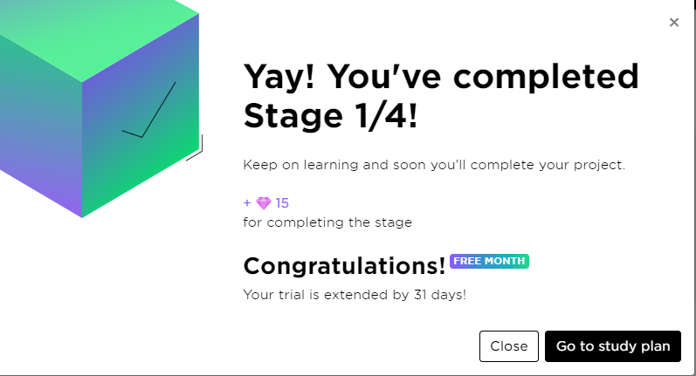

#### Short survey about your experience

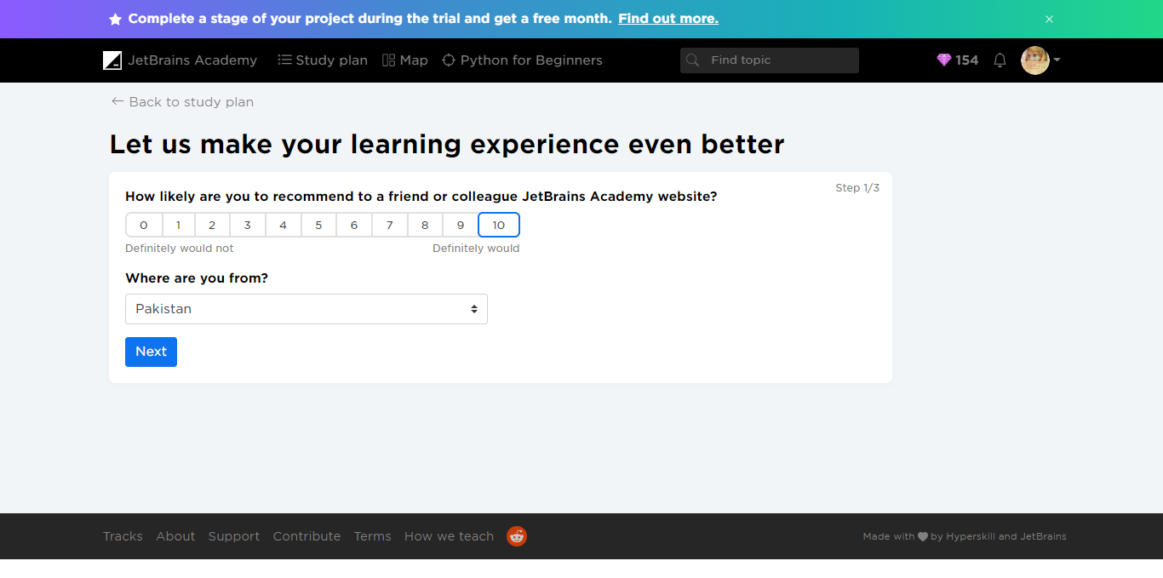

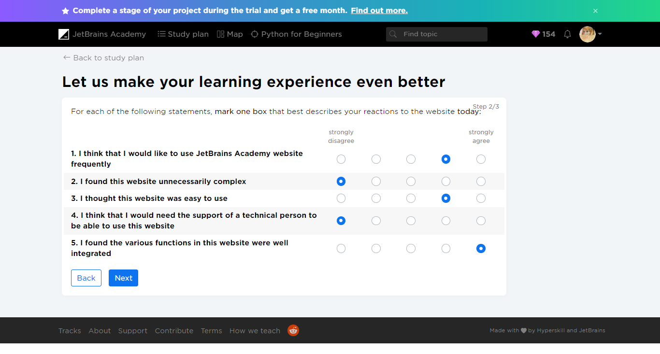

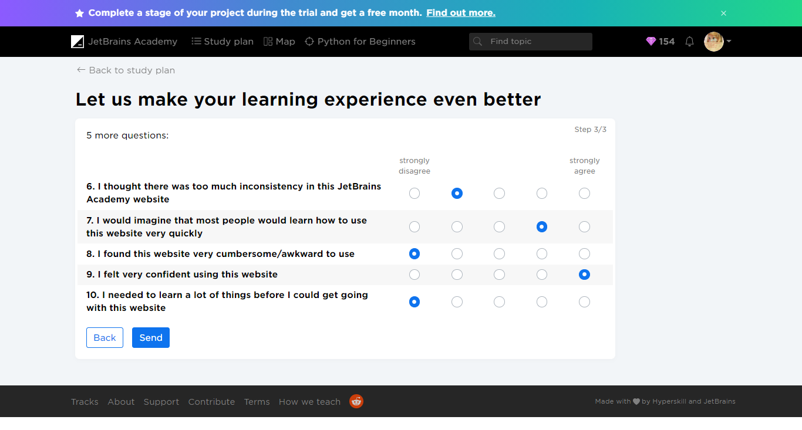



Survey completed!

**+  25gems**

Thanks for your feedback

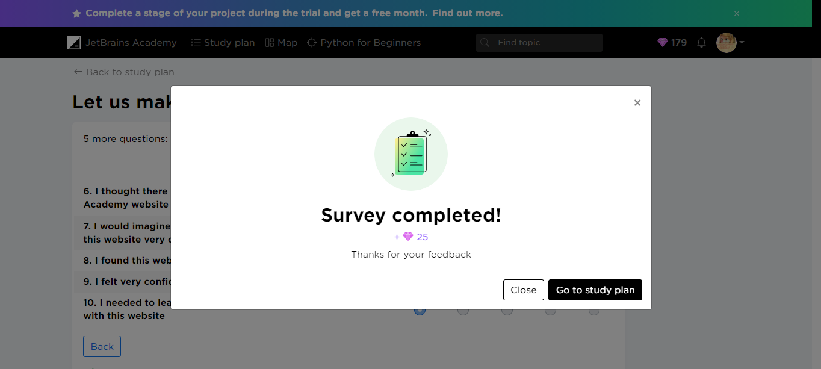

#### Stage 2/4: Show me an animal!

Show the zookeeper an image of her ward.

##### What you'll do in this stage 2/4: Show me an animal!

**Project:** [Zookeeper](https://hyperskill.org/projects/98) Hard  3 minutes

###### Description

One of the most important parts of working with animals is keeping an eye on them. We need to see the animals on the screen to know how they are doing, right? Now we are ready to print something awesome: an image of an animal!

###### Objectives

For the second stage, you will need to develop an animal printer. Your program should display the animal identified in the code field.

Please, don't remove the r character at the start of the code template. It's a part of the string and it's important. So, the string should start with r""" sequence. This “r” at the beginning stands for “raw” and allows various characters to be used in a string without escaping. For instance, “\” in a non-raw string should be escaped as follows: “\\”.

###### Example

Your output should contain the following ASCII image:

Switching on the camera in the camel habitat...  
 \_\_\_.-''''-.  
/\_\_\_  @    |  
',,,,.     |         \_.'''''''.\_  
     '     |        /           \  
     |     \    \_.-'             \  
     |      '.-'                  '-.  
     |                               ',  
     |                                '',  
      ',,-,                           ':;  
           ',,| ;,,                 ,' ;;  
              ! ; !'',,,',',,,,'!  ;   ;:  
             : ;  ! !       ! ! ;  ;   :;  
             ; ;   ! !      ! !  ; ;   ;,  
            ; ;    ! !     ! !   ; ;  
            ; ;    ! !    ! !     ; ;  
           ;,,      !,!   !,!     ;,;  
           /\_I      L\_I   L\_I     /\_I  
Look at that! Our little camel is sunbathing!

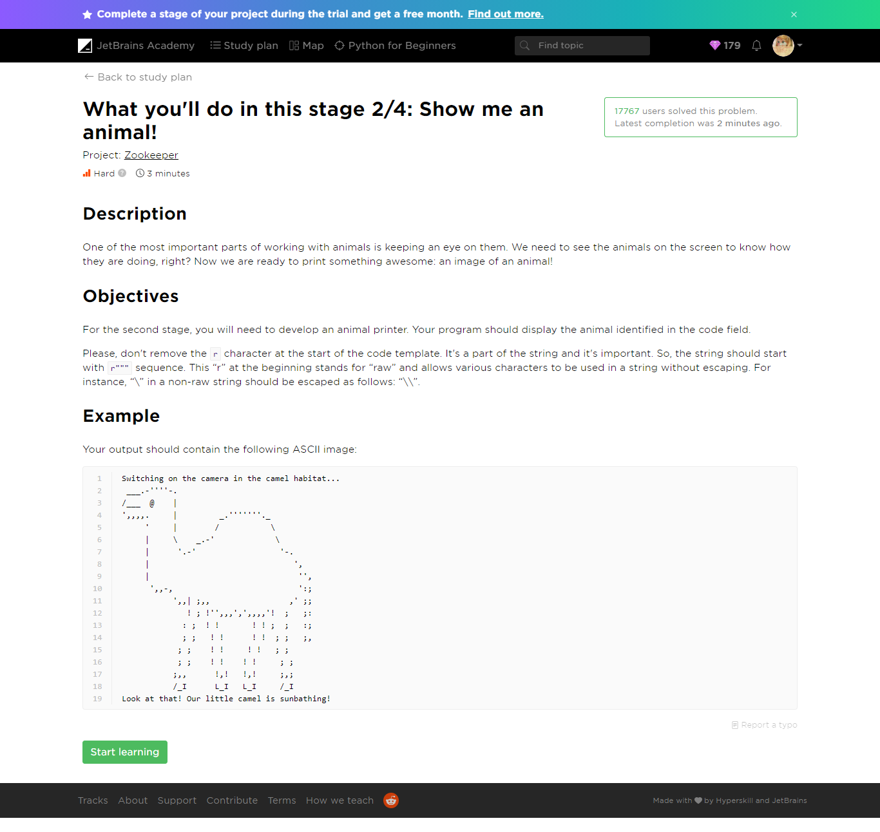

##### Theory: PEP 8

 6 minutes 0 / 5 problems solved

**Table of contents:**

[↑ PEP 8](https://hyperskill.org/learn/step/5879#step-title)

[§1. **PEPs**](https://hyperskill.org/learn/step/5879#-strong-peps--strong-)

[§2. The length of a line](https://hyperskill.org/learn/step/5879#the-length-of-a-line)

[§3. **Avoid extra spaces**](https://hyperskill.org/learn/step/5879#-strong-avoid-extra-spaces--strong-)

[§4. **Quotes**](https://hyperskill.org/learn/step/5879#-strong-quotes--strong-)

[§5. **What’s next?**](https://hyperskill.org/learn/step/5879#-strong-what-s-next---strong-)

[Feedback & Comments](https://hyperskill.org/learn/step/5879#step-feedback)

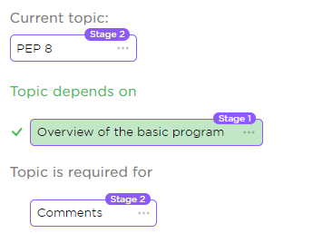

How to write code that is clean and easy to read? That is the question that you bump into when moving from simple single-line programs to more complicated ones. In the beginning, it may seem unimportant, but in real life, programming is a process that involves a lot of people that work together, so you spend more time reading code than writing it.

Although Python is often more readable than other programming languages because of its minimalistic syntax, just syntax itself is not enough. It is the way you write code that affects general readability. That is why you need to follow common conventions about programming style, so other programmers could read your code easily.

You may ask, where do these conventions come from? There is a document that is called[PEP 8](https://www.python.org/dev/peps/pep-0008/)[[1]](#footnote-2). The key idea of it is to use the same code style for all python projects as if they were written by the same programmer. This document guarantees that even a beginner will easily understand the code, written by any other developer.

###### ****PEPs****

Before going further, let’s talk about PEP for a moment. PEP stands for **Python Enhancement Proposal**. There are different types of PEP and the most useful one for beginners is the informational PEP. PEPs of this kind typically describe commonly accepted guidelines or conventions about the language, so they can be very helpful. Besides PEP 8, which is an official style guide, another great PEP to look at is [the Zen of Python](https://www.python.org/dev/peps/pep-0020/)[[2]](#footnote-3).

Since we know what PEP 8 is, let’s read a bit from it.

###### The length of a line

Do not use more than 79 characters in a line of code. Shorter lines look better in code editors. During this course, we will learn several ways to achieve it.

###### ****Avoid extra spaces****

Sometimes you may add some spaces even if you don't really need it. This will reduce the readability of your code.

* **Avoid extra spaces within parentheses.**

Good:

print('Hello!')

Bad:

print( 'Hello!' )

* **Avoid an extra space before an open parenthesis.**

Good:

print('some text')

Bad:

print ('some text')

###### ****Quotes****

As it was already mentioned, you can use either single or double quotes to define strings. Please, choose one that you like the most and consistently use it in your code. The only recommendation in PEP 8 is that if a string contains single or double quotes, you should use the other one to avoid backslashes.

Good:

print("It's a good string!")

Bad and harder to read:

print('It\'s a bad string!')

As you can see, the first example is easier to read.

###### Problems

PEP 8 -> What is better for a program

Easy 24 seconds

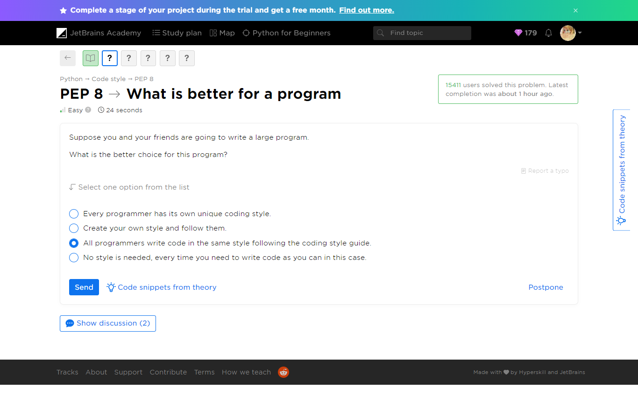

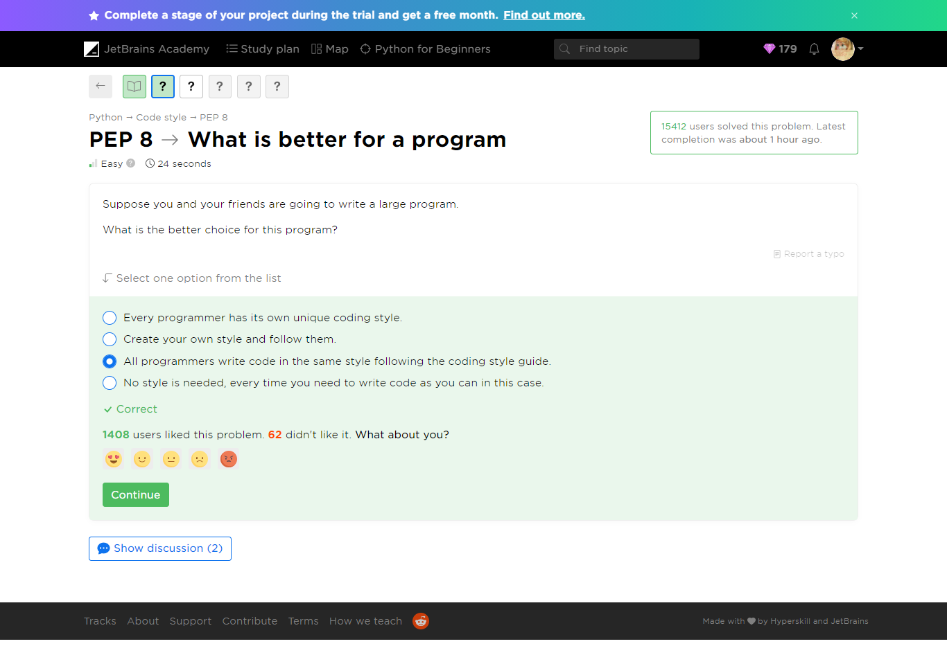

[PEP 8](https://hyperskill.org/learn/step/5879) -> Where is it?

 Medium  18 seconds

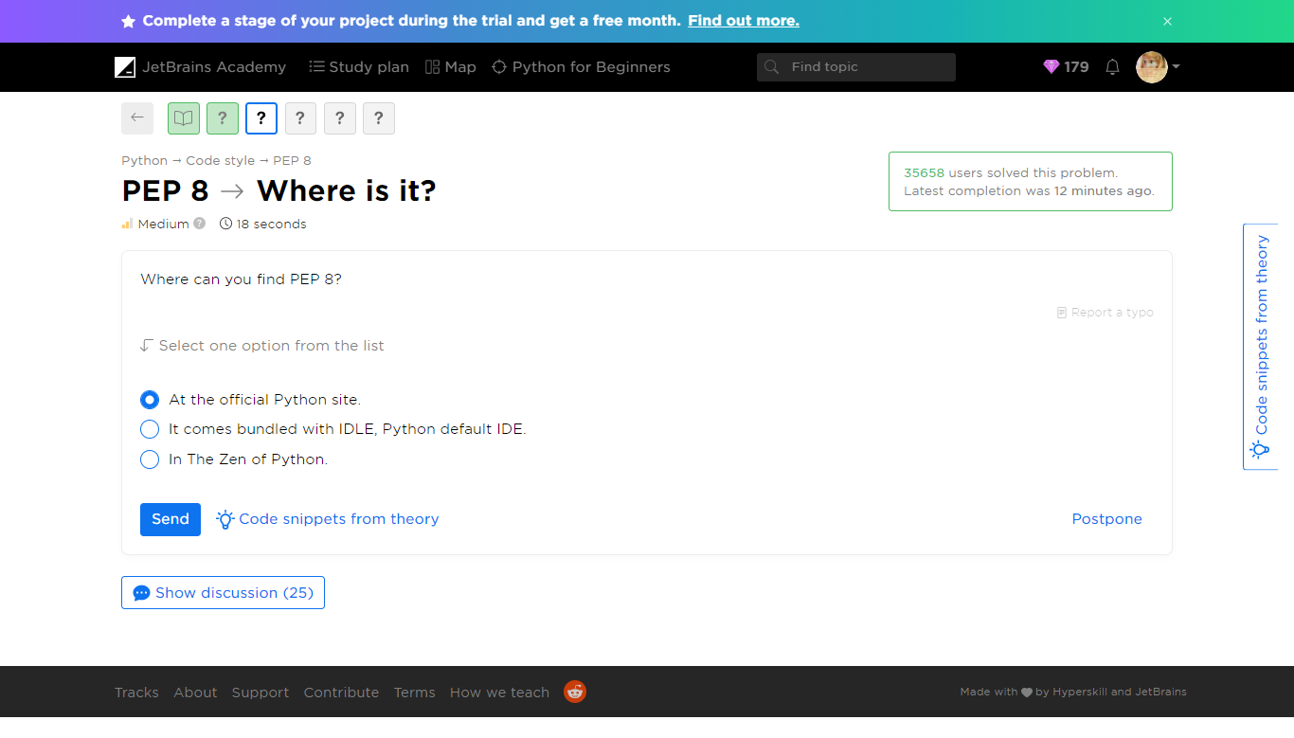

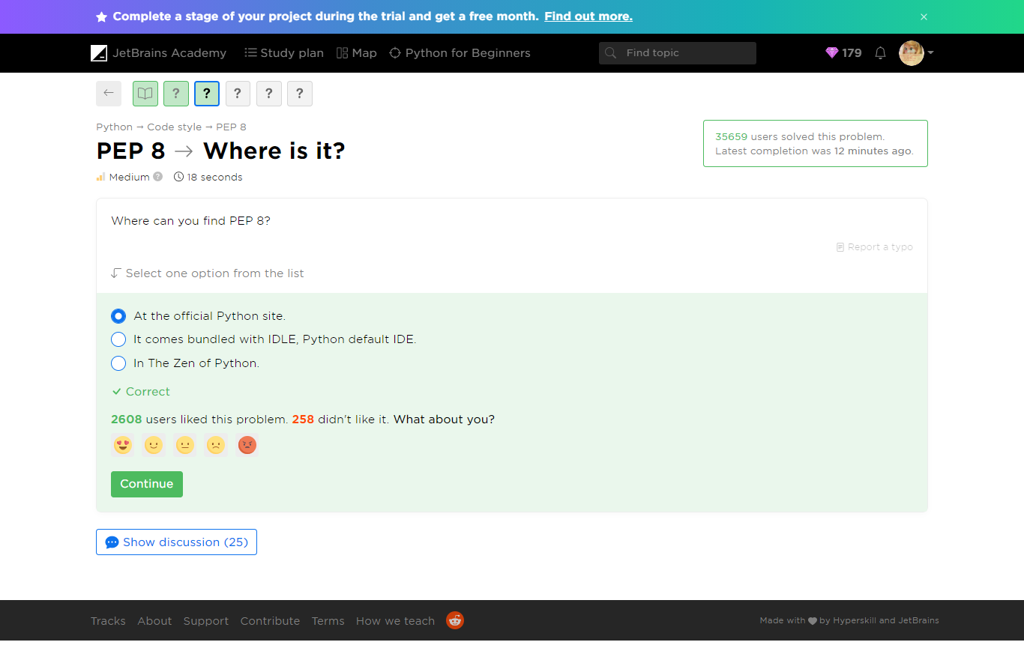

[PEP 8](https://hyperskill.org/learn/step/5879) -> Extra spaces

 Easy  1 minute

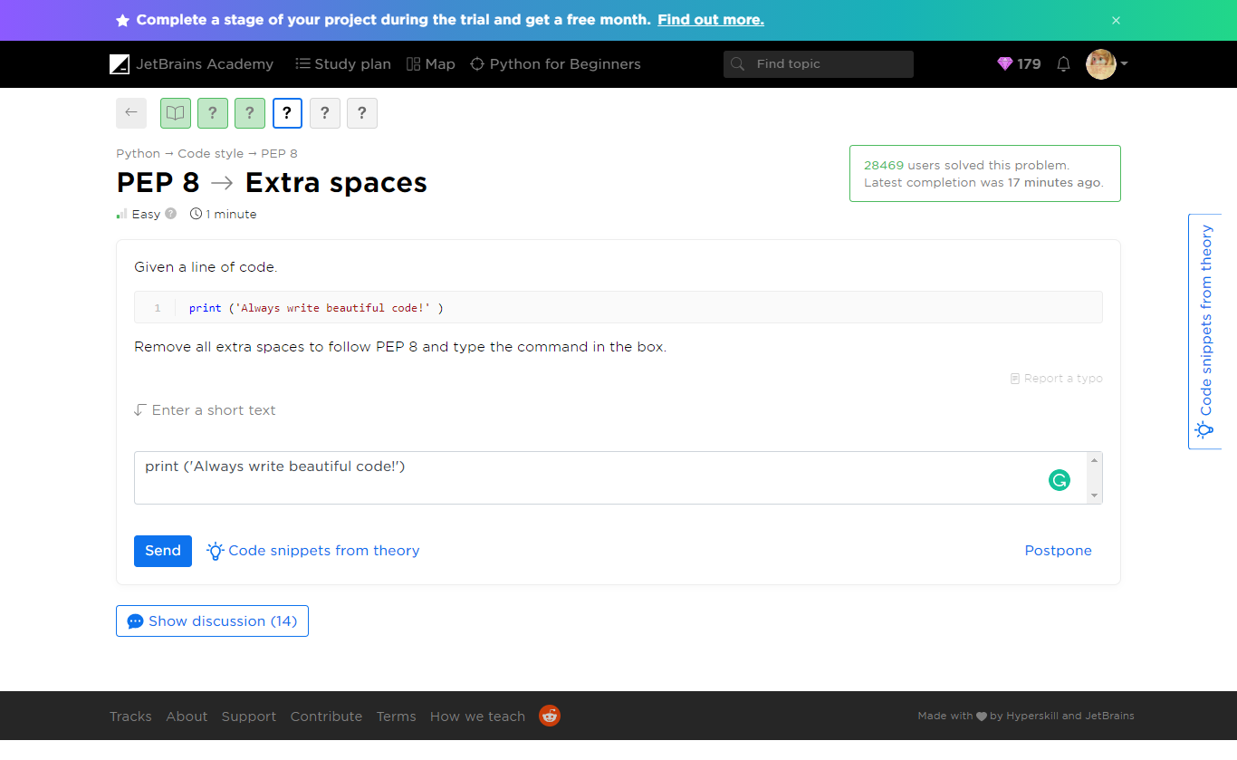

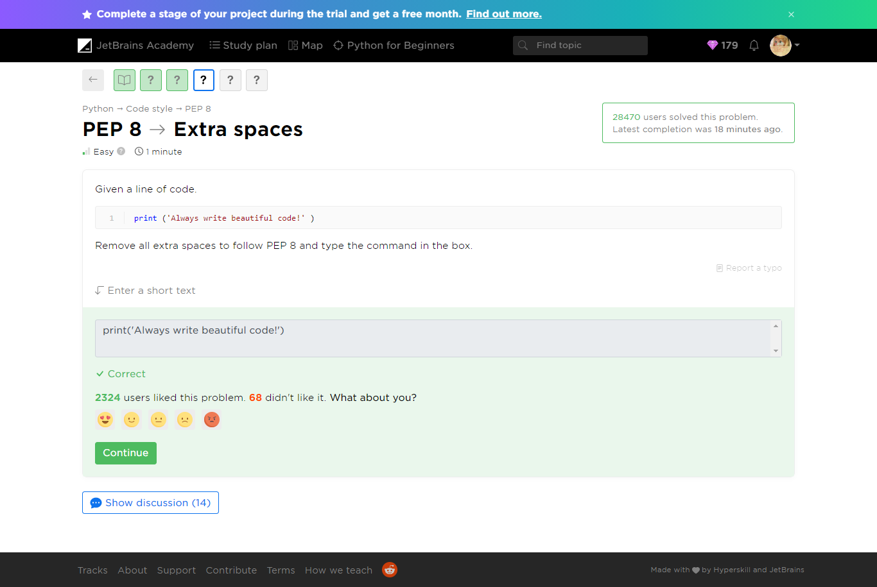

[PEP 8](https://hyperskill.org/learn/step/5879) -> Select strings

 Medium  1 minute

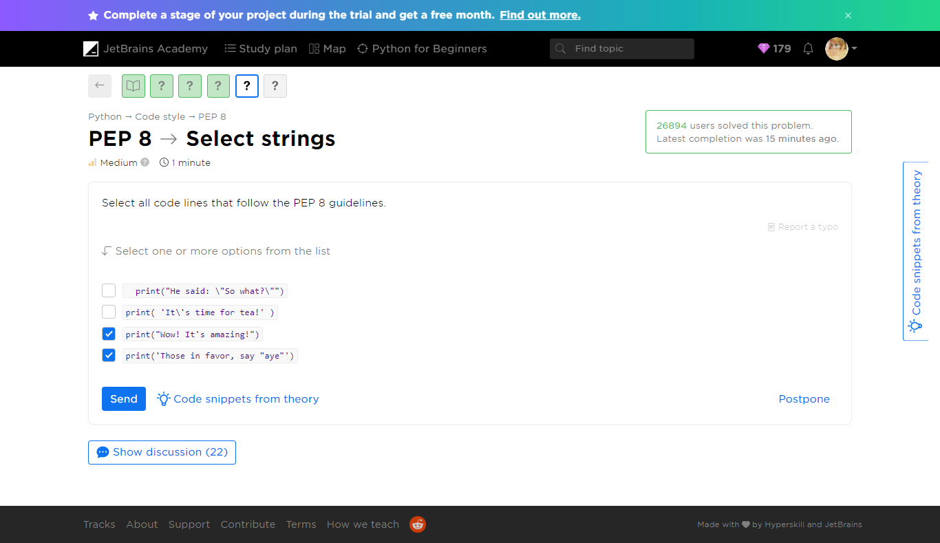

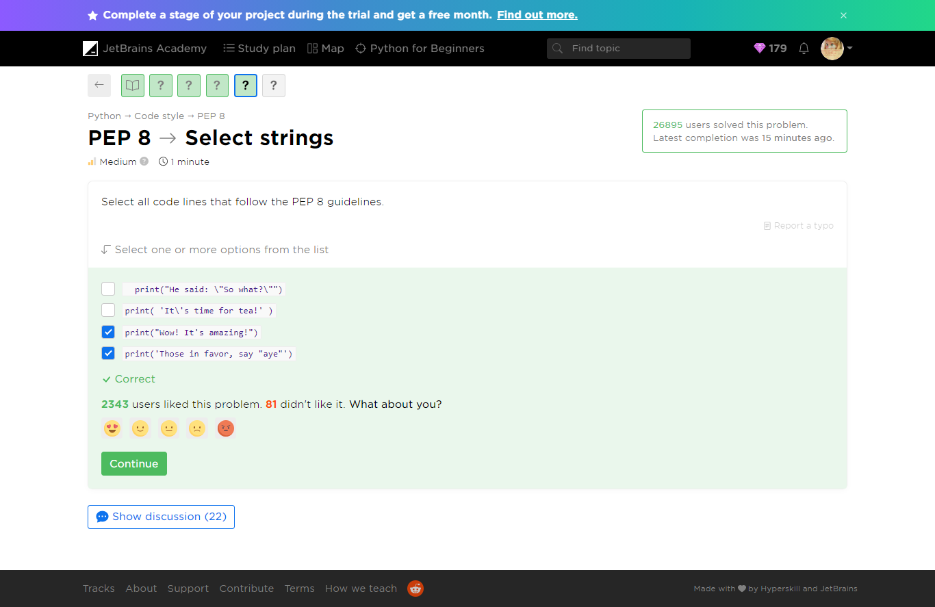

[PEP 8](https://hyperskill.org/learn/step/5879) -> Rules

 Medium  1 minute

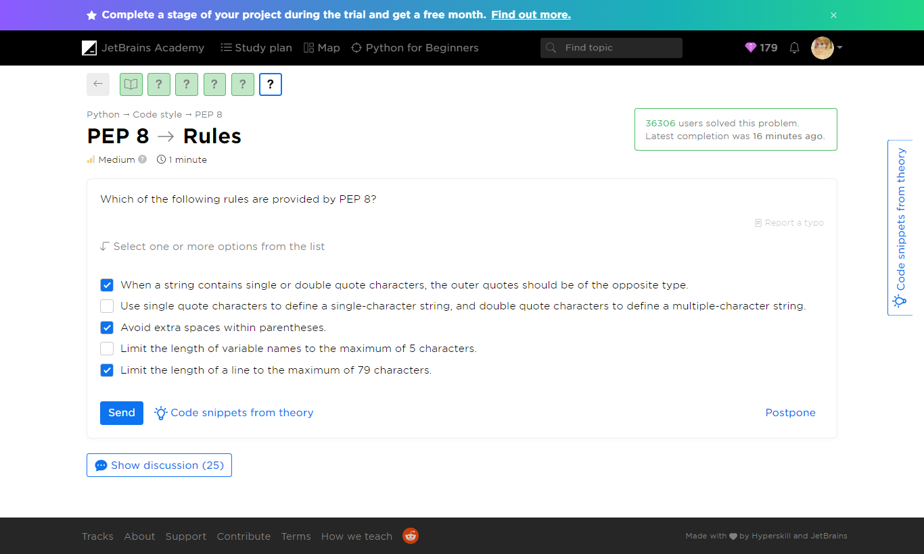

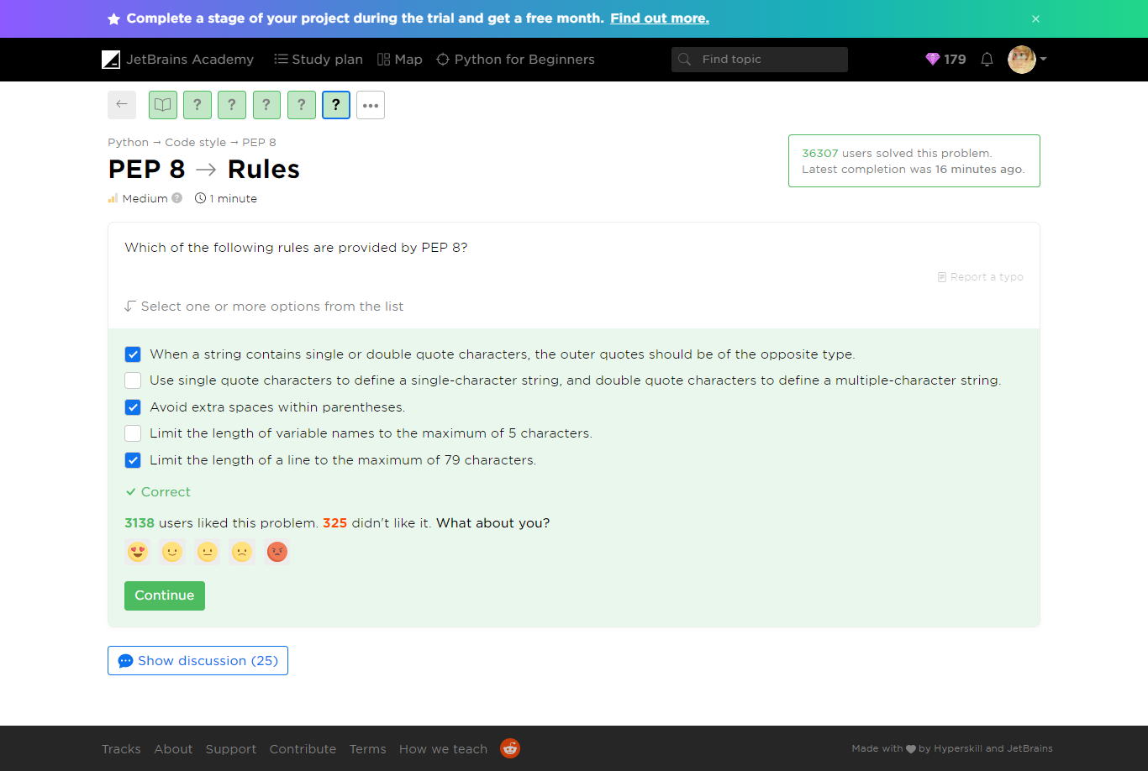

Yaaay!

You completed **PEP 8**

**You solved: 5 problems**

1. What is better for a program

2. Where is it?

3. Select strings

1. Extra spaces

2. Rules

**More to solve (optional): 4**

1. Length of lines

2. What is it?

3. PEP in PEP 8

4. Unconventional code

###### Additional Problems

[PEP 8](https://hyperskill.org/learn/step/5879) -> Length of lines

 Easy  13 seconds

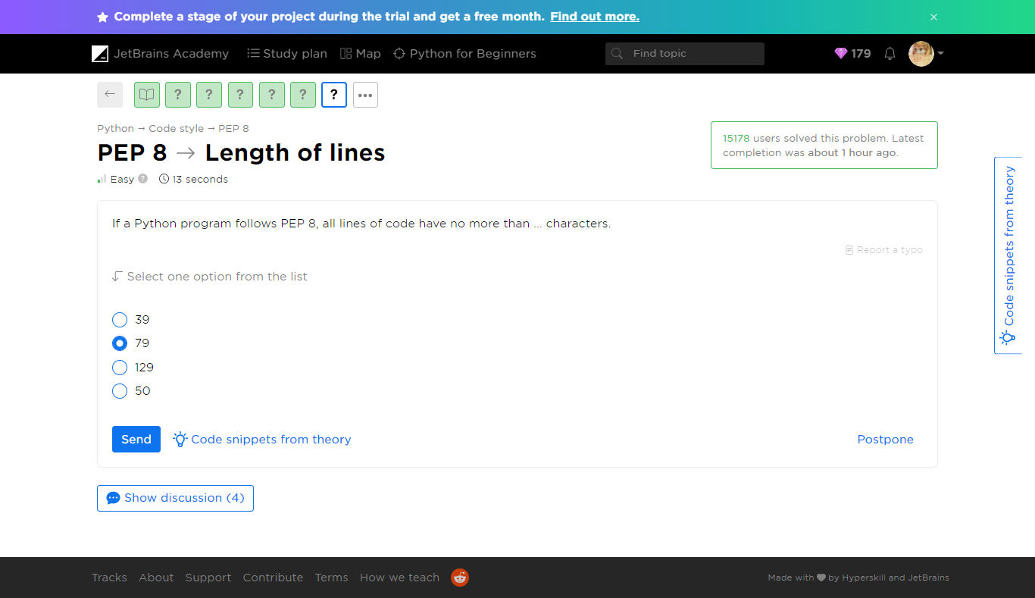

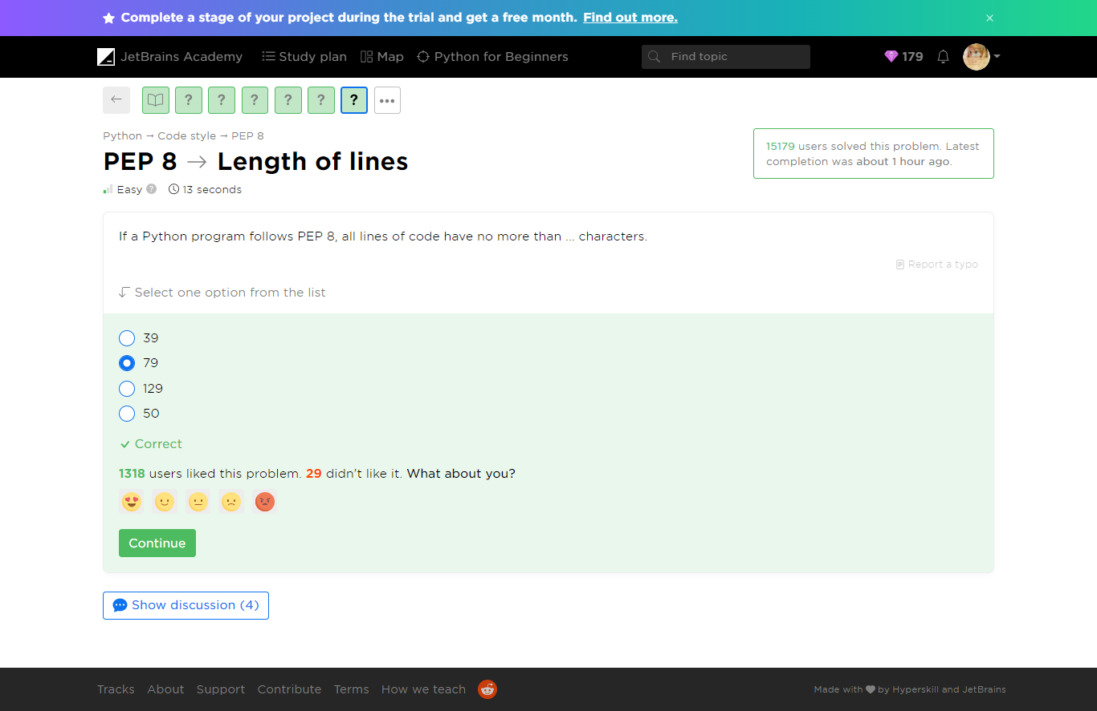

[PEP 8](https://hyperskill.org/learn/step/5879) -> What is it?

 Easy  19 seconds

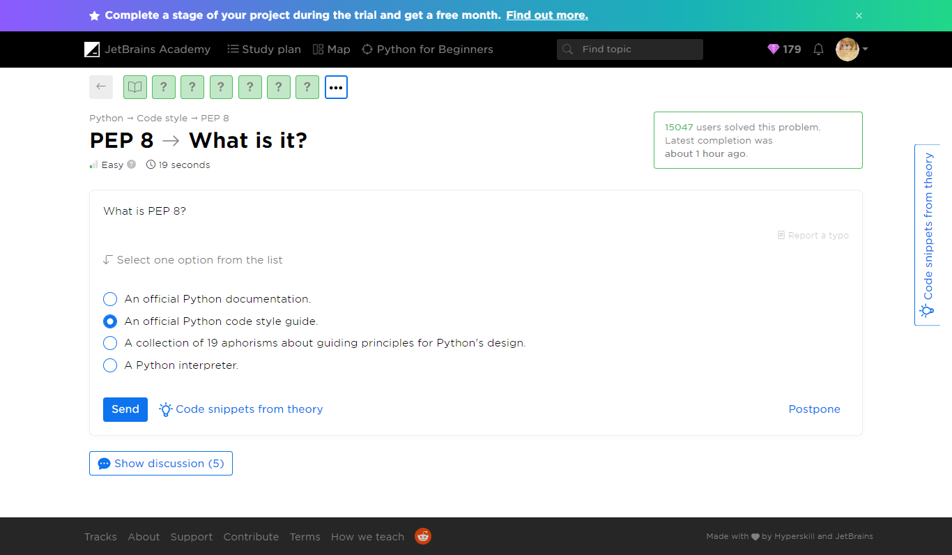

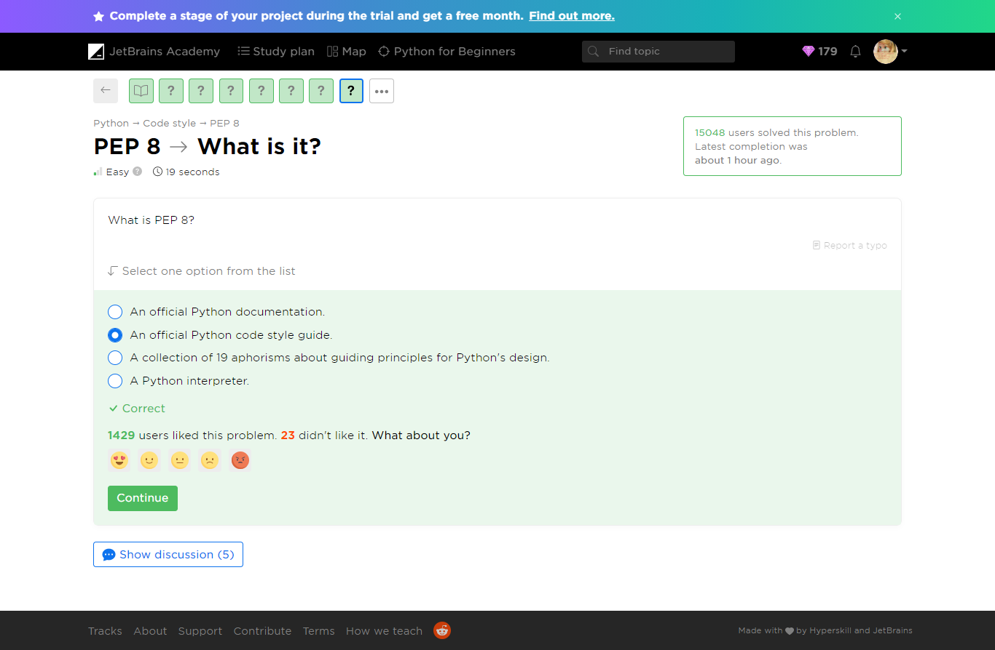

[PEP 8](https://hyperskill.org/learn/step/5879) -> PEP in PEP 8

 Easy  14 seconds

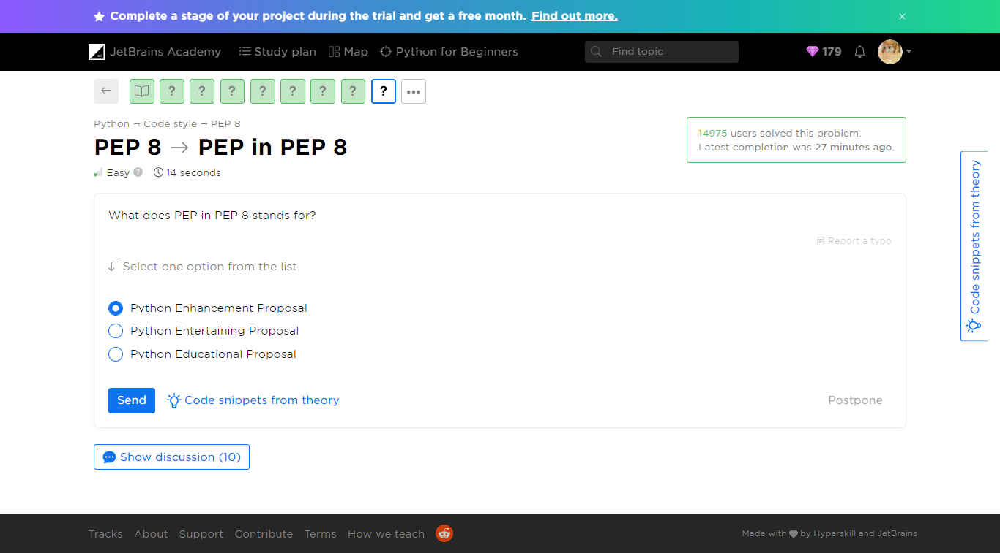

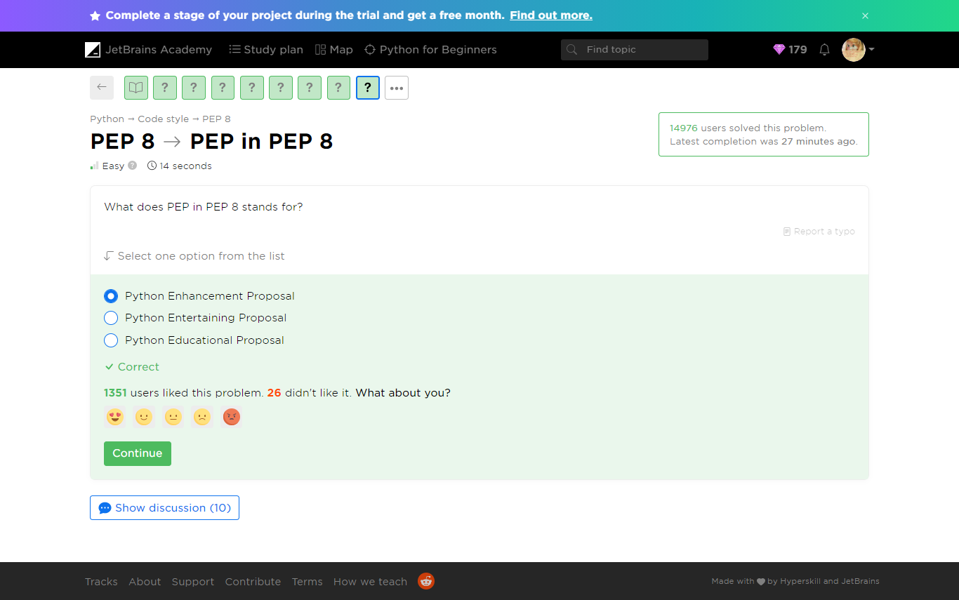

[PEP 8](https://hyperskill.org/learn/step/5879) -> Unconventional code

Medium  1 minute

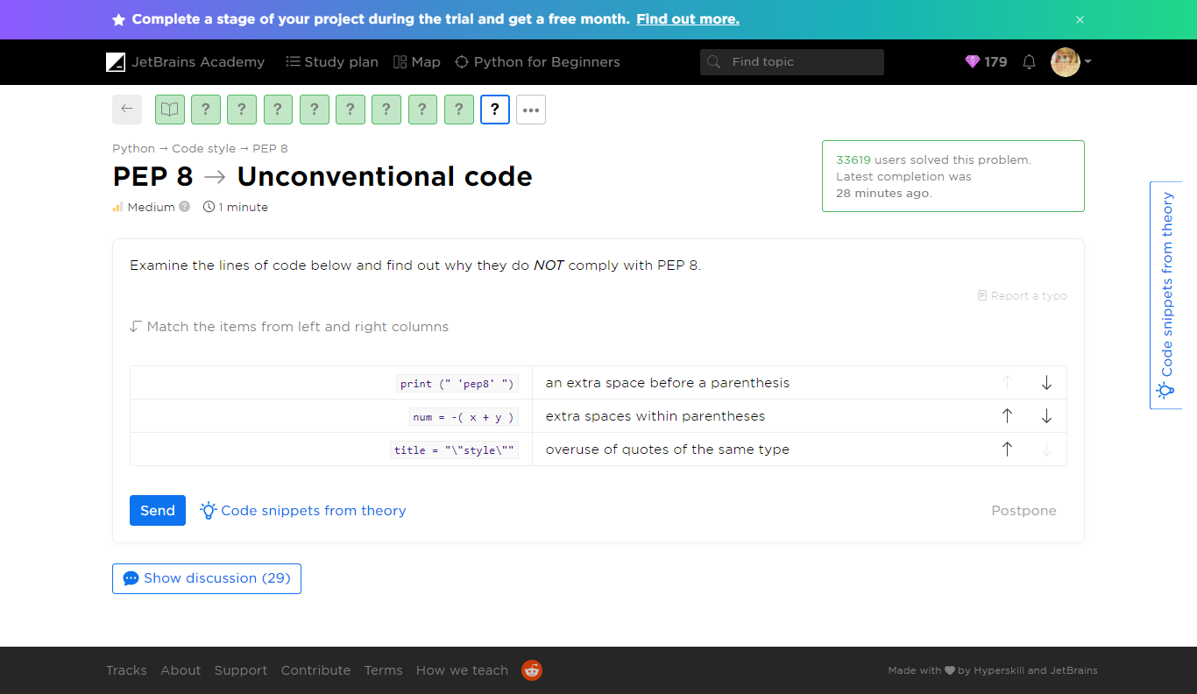

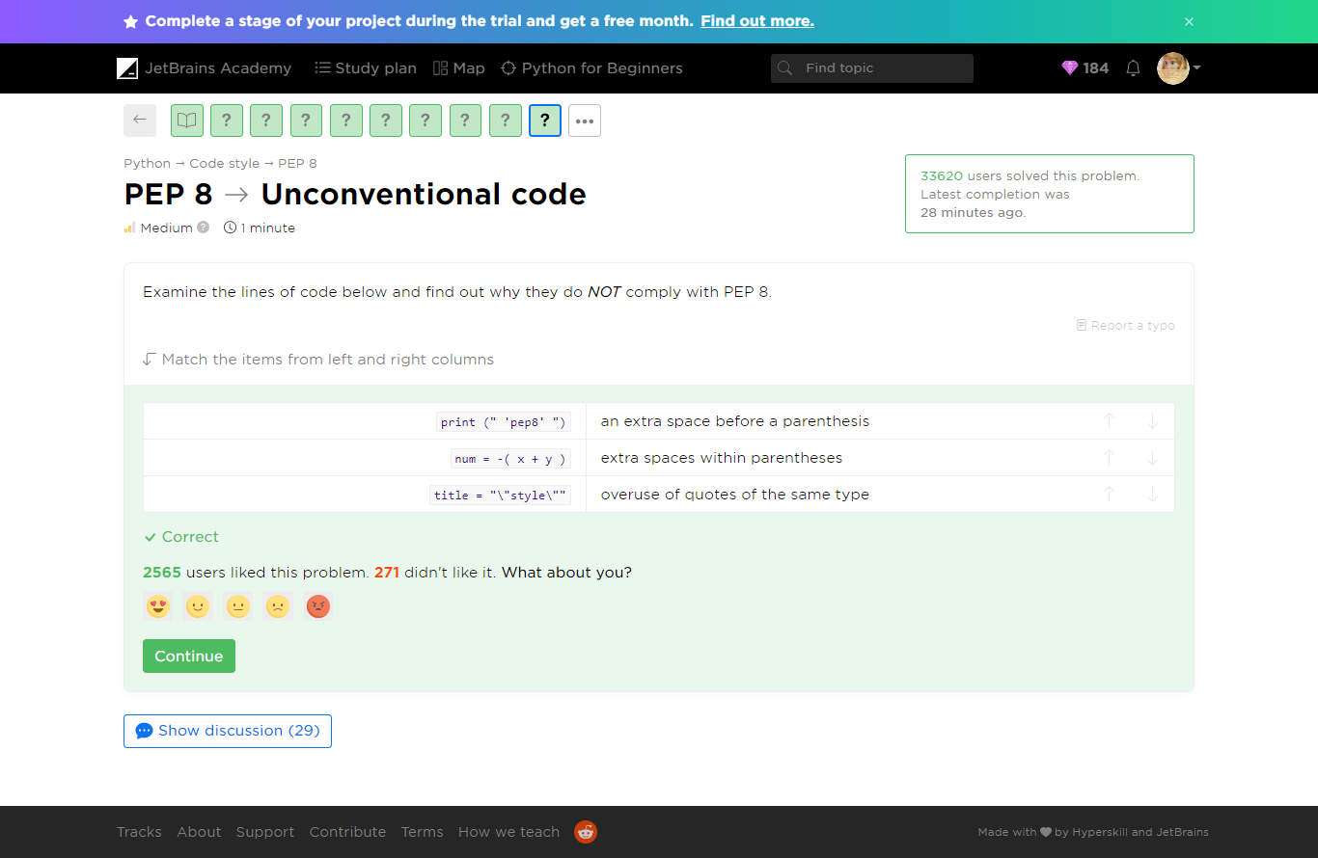

Yaaay!

You completed **PEP 8**

**You solved: 9 problems**

1. What is better for a program

2. Length of lines

3. What is it?

4. PEP in PEP 8

5. Where is it?

1. Select strings

2. Extra spaces

3. Rules

4. Unconventional code

###### ****What’s**** next?

Later, you will learn a lot of things about Python and become a more skillful programmer but following the code style will always remain important. Do not worry, though: you do not need to learn all the conventions at once; just open them from time to time after learning something new. We will also give parts of these conventions in this course.

##### Theory: Comments

 7 minutes 0 / 5 problems solved

Sometimes you need to explain what some particular parts of your code are for. Lucky you, since Python gives you an opportunity to fulfill your needs. You can leave special notes called **comments**. They are especially useful for beginners. Throughout this course, we will often use comments to explain our examples.

###### What is a comment?

Python comments start with a **hash #**. Everything after the hash mark and up to the end of the line is regarded as a comment and will be **ignored**when running the code.

print("This will run.")  # This won't run

In the example above, you can see what PEP 8 calls an**inline**commentbecause it's written on the same line as the code.

A comment can also refer to the block of code that follows it:

# Outputs three numbers  
print("1")  
print("2")  
print("3")

We intend to use such comments primarily for learning purposes. Now, it's time to find out how to comment code properly.

###### Formatting comments

Although it is pretty easy to write a comment, let's discuss how to do this in accordance with best practices.

To begin with, after a hash mark there should be **one space** and, in inline comments, there should be **two spaces** between the end of the code and the hash mark. Putting more than two spaces between the end of the code and the hash mark is also acceptable but most commonly there are exactly two spaces.

print("Learning Python is fun!")  # This is a proper comment formatting  
print("PEP-8 is important!")#This is a very bad example

Indent your comment to the same level as the statement it explains. E.g. the following example is wrong:

    # this comment is at the wrong place  
print("This is a statement to print.")

A comment is not a python: it should not be too long. Following PEP-8, the comment length should be limited to 72 characters. It's better to split a long comment into several lines: you can do it by adding a hash mark at the beginning of each new line:

# Imagine that this is an example of a really long comment  
# that we need to spread over three lines, so we continue  
# to write it even here.  
print("The long comment above explains this line of code.")

Comments that span multiple lines are called **multi-line** or **block** comments. In Python, there is no special way to indicate them.

You may come across multi-line comments enclosed in triple quotes """...""", still, we recommend that you use several hash marks for this purpose. Thus, your code will comply with the [official style guide](https://www.python.org/dev/peps/pep-0008/#block-comments). Triple quotes are reserved for **documentation strings**, or **docstrings**for short. They are also informative, but their use is limited to functions, methods and several other cases.

We hope our comments will help you understand our code examples better!

**Current topic:**

[Comments](https://hyperskill.org/learn/step/6081" \t "_self) Stage 2

**Topic depends on**

[Multi-line programs](https://hyperskill.org/learn/step/5233" \t "_self) Stage 1

[PEP 8](https://hyperskill.org/learn/step/5879" \t "_self) Stage 2

**Topic is required for**

Avoiding bad comments

[Basic data types](https://hyperskill.org/learn/step/5852" \t "_self) Stage 2

**Table of contents:**

[↑ Comments](https://hyperskill.org/learn/step/6081#step-title)

[§1. What is a comment?](https://hyperskill.org/learn/step/6081#what-is-a-comment-)

[§2. Formatting comments](https://hyperskill.org/learn/step/6081#formatting-comments)

###### Problems

Comments -> What is a comment?

*Easy*

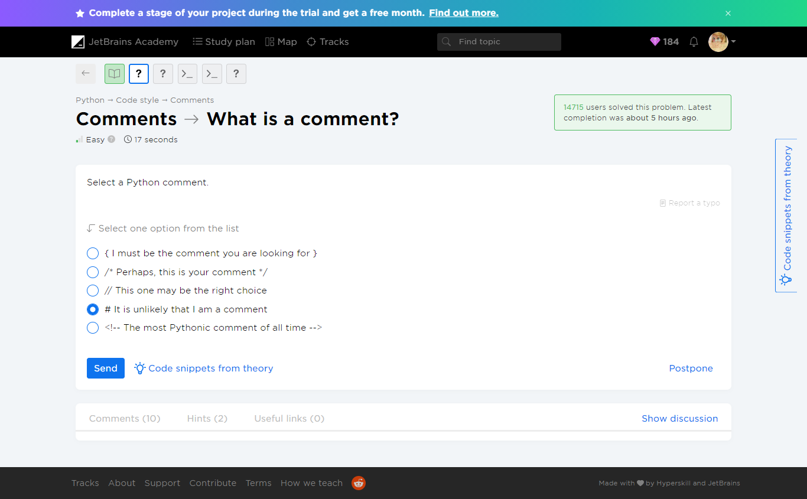

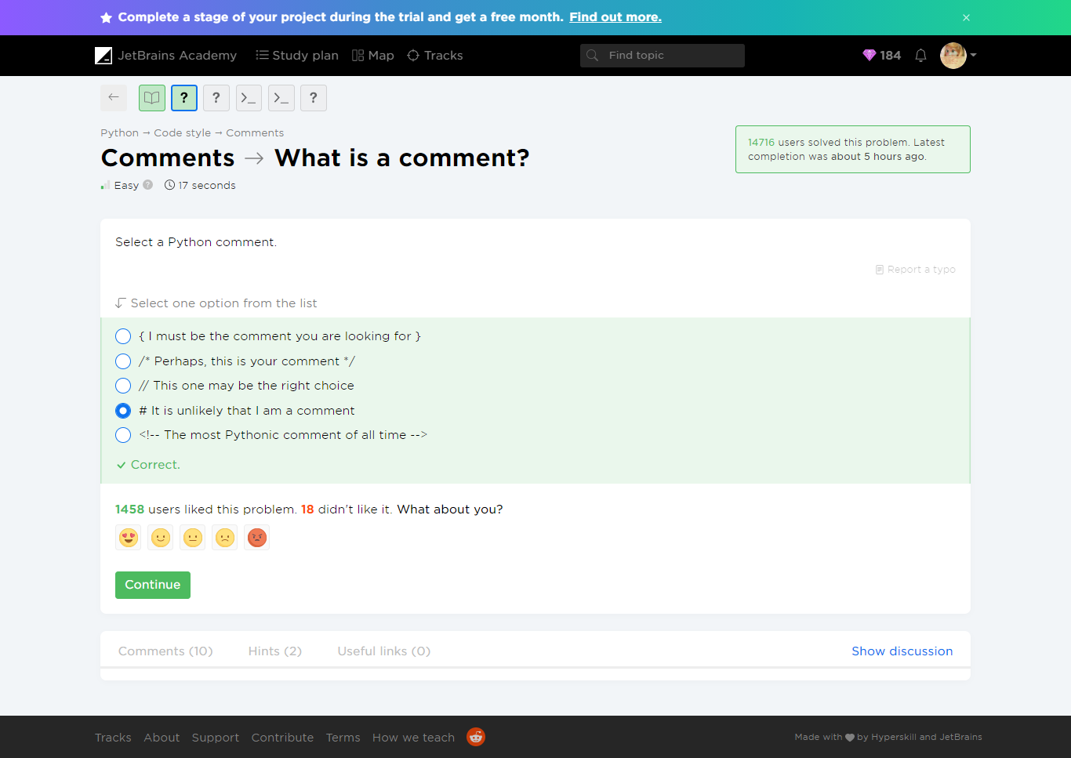

Comments -> Good comment

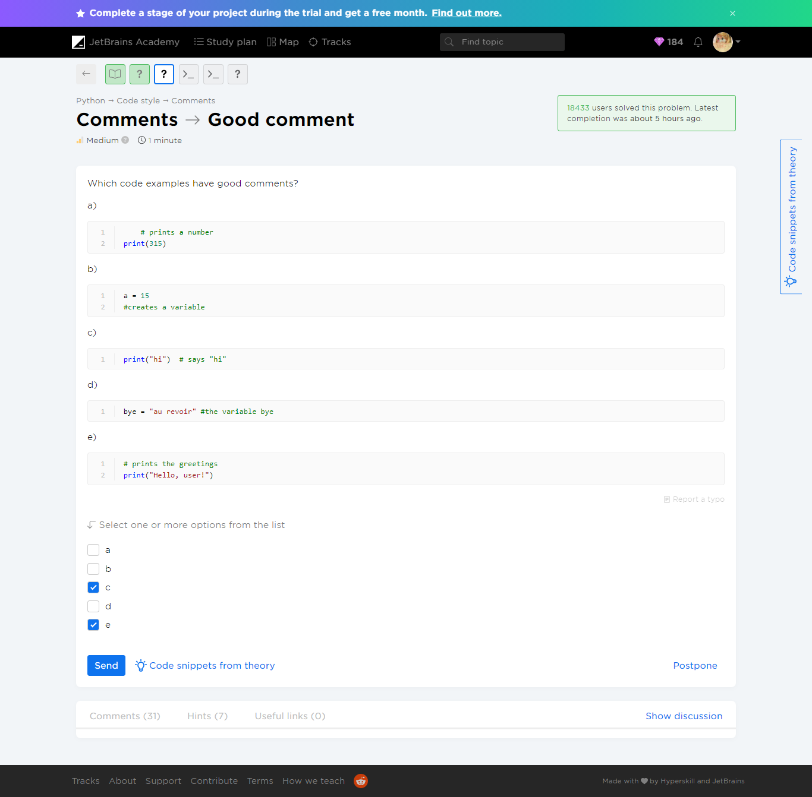

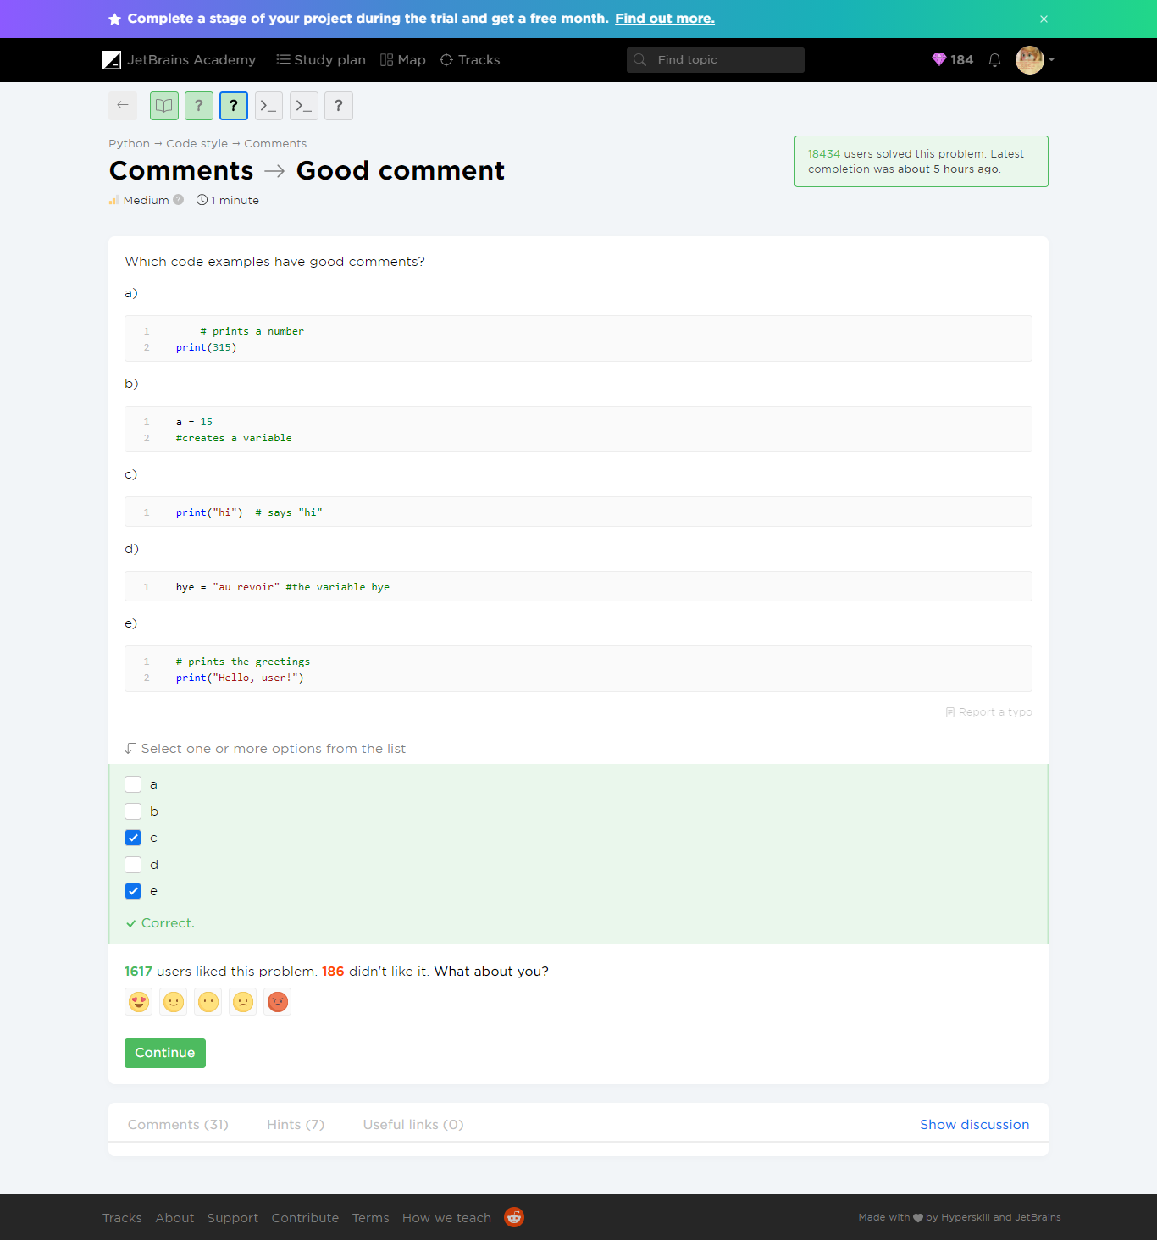

Comments -> Where are the comments?

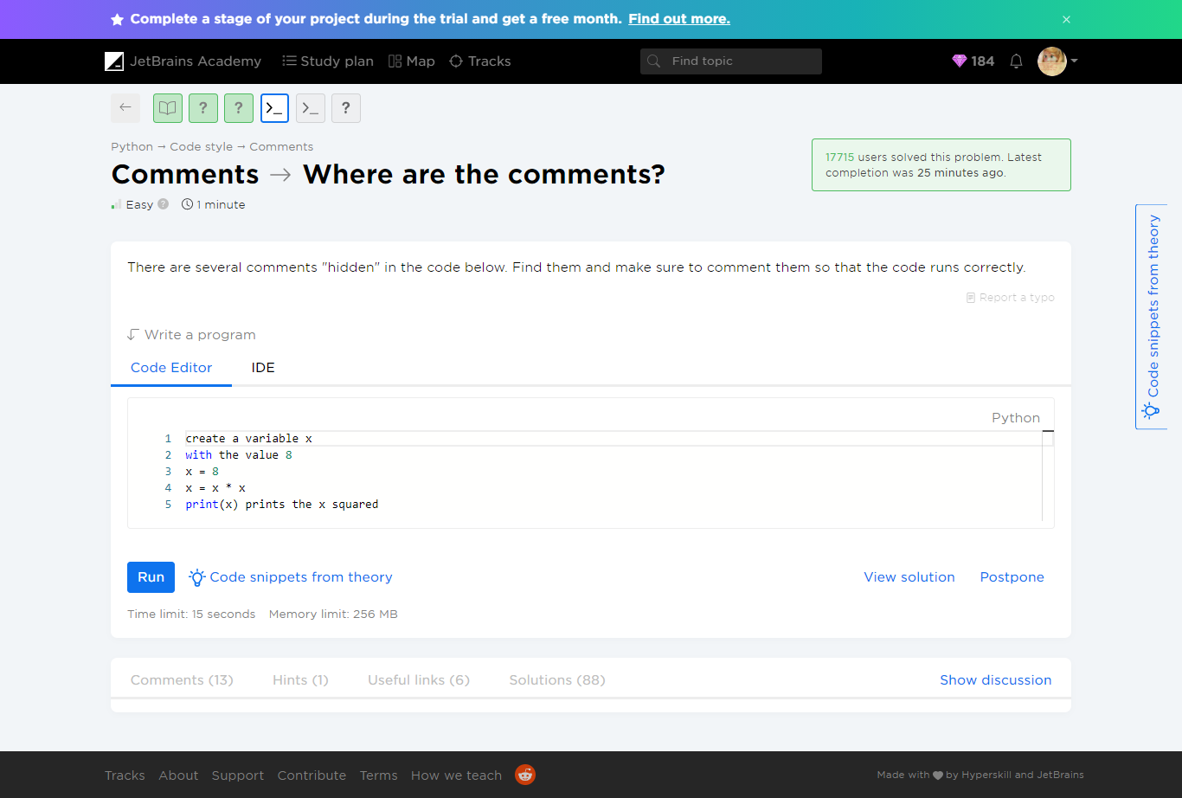

#### Stage 3/4: What's inside?

The zookeeper wants to know what is inside each habitat, by its number.

#### Stage 4/4: Sustainable care <3

Finally, your program can work for as long as needed!

### Result will look like

(see [demonstration.mp4](file:///C:\Users\maham\AppData\Roaming\Microsoft\Word\JetBrains%20Academy%20-%20Python%20for%20Beginners\demonstration.mp4))

1. <https://www.python.org/dev/peps/pep-0008/> [↑](#footnote-ref-2)
2. <https://www.python.org/dev/peps/pep-0020/> [↑](#footnote-ref-3)